C E C I L I A J A I M E

P ORTFOLIO

C E C I L I A J A I M E

A B O U T

ABOUT CECILIA JAIME
Cecilia Jaime (1962) is an Argentinian - Belgian visual artist based in Ghent, Belgium. She graduated in the Master in Fine Arts, with specialization in Painting , by the Faculty of Arts, at the University of Tucumán, Argentina, in 1987. She worked on the project “ Surco”, an experiment of art in Nature, at the Northwest of the Argentinian Andes. From 1985 to 1987 she was an assistant lecturer in the Faculty of Art at the same University. In 1988 she received the prestigious Grant from the National Arts Funds in Buenos Aires. From 2012 she runs Cecilia Jaime Gallery in Gent, Belgium and is art consultant for important collections.
Since 1989 she lives in Belgium. In de period of 2003-2006 she worked in a social artistic project: “Scratch”, from the Fine Arts Museum in Ghent. She also gave workshops at S.M.A.K. (Stedelijk Museum voor Actuele Kunst- Municipal Museum of Contemporary Art),Ghent. She has given Master classes in painting and drawing in Ghent (2006-2009). From 2006 till today she is a resident artist at Nucleo vzw ( Belgium). From 2008 she follows the Sculpture specialty at the Academie voor Beeldende Kunst in Ghent, Belgium. She also has been a consultant artist for the architects studio of Bob Van Reeth, in 2010 and 2014. She has presented her work in numerous international projects in Latin America and Europe: group exhibitions, solo shows, art fairs, in several cultural centers, museums, events and public spaces. Her Works are in collections in Argentina, Belgium, Switzerland, France and Germany.
International projects and exhibitions are: Splav Meduze -Curator Marko Stamenkovic at the Center of Contemporary Art, Celje (2009) Slovenia; De Collectie - Curator Philippe van Cauteren, Director of the Municipal Museum of Contemporary Art in Ghent; CC TEN NOYE, solo show, Brussels (2010). Her video-performance ‘Desierto de los olvidos’ was presented at the LAKMA Museum, in The Netherlands (2011). She has shown her works in an installation with photography, sculptures, video and paintings, ‘Stills and Movements’, at the Caermersklooster in Ghent; The group exhibition De Connectie - Curators A.Quireyns, for Air Antwerpen, and F. De Preester, in Gent (2011). She has been invited to join the Artwiki of the Open Call project of the 7th Berlin Biennale (2012), with Curator Artur Zmijewski and Associate Curator Joanna Warsza. Other important group exhibititons at Flemish Parliament Brussels Administration/Embassy of Argentina (2013),"Marina Art" at the University of Ghent , Fort Napoleon, Oostende (2013), Museum Dhondt -Dhaenens Auction Paddle8 & Christie’s (2014) at Deurle, "Someone like you" , Galerie Hommes Rotterdam (2014). BAD (Belgian Art and Design) , K.V.D.M at Zebrastraat Kunstplataform 2016. Solo Show paintings and sculptures at Cecilia Jaime Gallery and Solo Show at Kasteel Claeys Boüuaert,Gent 2017.'Gardens',Solo Show at Cecilia Jaime Gallery 2018. 'On the Move', Group show Blanco,2018.Group show Cecilia Jaime Gallery Gent 2018.Solo Show BAD Belgian Art & Design,Gent 2019. 2020 Solo Show BLANCO Gent relocated in Cecilia Jaime Gallery(Corona Pandemie). SUMMER CAMP #6.OPEN STUDIOS NUCLEO 2020
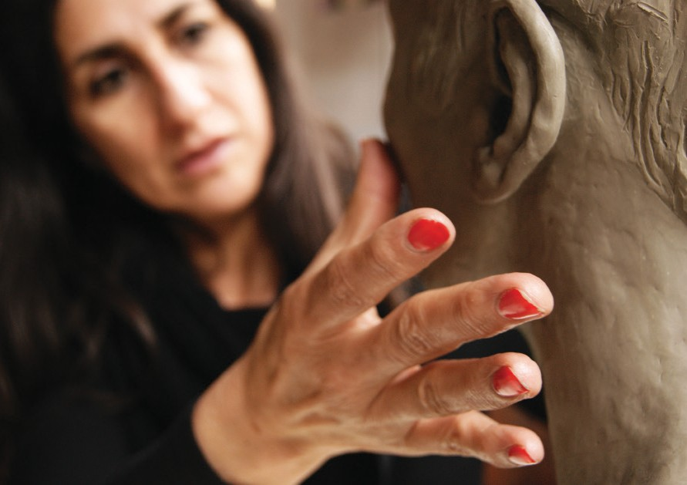

CECILIA JAIME’S STATEMENT

Visual artist Cecilia Jaime lives and works in Ghent, Belgium, where she has continued to develop her career through exhibitions over the past thirty years. Her work consists of sculptures, installations, draw- ings, paintings, video work, and photography. The contents of each work determine the medium that the artist ultimately selects.

Her work has been for a long time a contemplative representation of emotions and thoughts about people she met or imagines from an inexistent world or memories. These are memories of people in their everyday life, such as in a market or in an airport; people captured in a fiction world, but represented in a realistic form sometimes, or in exaggerated movements other times.

Born in the Northwest of Argentina, she grew up in the period of Argentinian censorship in the 70’s; a censorship that not only intervened in the political, economical and social life, but also in the culture. At the end of that period in the 80’s, the new «liberated» literature, theatre plays, television programs, musicals, etc. shocked the artist.

She has a large experience as a painter, and her way of thinking through the drawings was sometimes the beginning of a composition or the final work. Nowadays, she works mainly with sculptures, photography, video and drawings.

There are new social and cultural contents in her most recent works. Life experiences, travels, memories, great environment changes in the world and the developments in media and technology drove the artist into new reflections and into using new and more diverse mediums to express her ideas.

The installation, “Stills and Movements” (2011), shows a development of a new visual perspective: facts hap- pen in space and time. Personal memories and a historical process in the artist’s timeline can be recognized in de video performance “Desierto de los olvidos”.

In 2007 Cecilia Jaime developed an important landscape photographic work –Photography is combined with a dramatic and poetic tranquility-. The place chosen was the highest salt desert of the Argentinian Andes, 2500 kms away from Buenos Aires.
In 2009 she went back to the same place to make a short film with the same weather conditions as before; with the perfect blue sky as in 2007. A video performance was filmed in the salt desert where a woman continually falls, as memories of past moments. A storm of wind and salt at 110km/h created a dramatic abstract sphere that appears to be taken in an unreal planet. The falling woman became the Falling Man in her sculptures. Here a new creative process started: a more spatial work. Cecilia Jaime’s last sculptural works are her own reflections about social events when women were criticized for sexism (vid the facts that occurred in Canada, 2010).

“The Leveller” (2013) is a miniature sculpture which she uses to exalt her interest in the warming up of the earth and the changing sea level in our oceans.
With “The Cape man” (2013), the artist tries to make reflections about the effects of the wind and the fast changes in our climate.
With “Face to face” (2013), Cecilia Jaime dedicated an exhibition to her own artistic work. “Face to face”, not only refers to the confrontation with one’s own identity, but also to the encounters between people. Bringing people together was one of the incentives for Cecilia Jaime to start her gallery.

In 2015 IMAGINE is the exhibition where the nature take a new place again in her work. Installations with jungle photographs, plants drawings, landscapes paintings and sculptures are the context in her shows at Cecilia Jaime Gallery (2017,2018), Kastel Claeys-Bouuaert in 2017 and On the Move,at Blanco,Nucleo,2018). In her Solo show in BAD Fair 2019 she will presents a new bodie of works with plants, lakes and landscapes with infinite perspectives as a constant interest in our environment changes.

EXHIBITIONS
SOLO EXHIBITIONS

2020-Solo Show Cecilia Jaime- BLANCO, door Corona verplaats naar Cecilia Jaime Gallery,Ghent
2019 - Solo presentation in BAD/ Fair Belgian Art & Design/ Gent
2018- Solo show Cecilia Jaime , Kastleel Claeys-Bouuaert , Gent. Ambassade of Argentine& City of Ghent
2018 - Solo Show Gardens - Cecilia Jaime Gallery - Gent
2017- Solo Show Cecilia Jaime Paintings & Sculptures / Cecilia Jaime Gallery
2013 - Face to Face / Cecilia Jaime Gallery, Ghent
2011 - Stills & Movements#Cecilia Jaime-Sculptures/Paintings/videoinstallatie Caermerklooster-Gent / Opening Speech : Frank Beke
2010 - Summer Show Sculpture /Paintings-Cecilia Jaime Art Space -Gent 2010 - CC Ten Noye-Brussel
2009 - YEUNG - Paintings Cecilia Jaime - 9000 Gent
2007 - Zebrastraat Meeting Point – Ghent; Ambassade van Argentinië 2005 - Art Cube - Finale evenemets / Eskimo - Ghent.
2005 - Open atelierdag – Nucleo - Ghent 2004 - Open Atelier-Nucleo KunstLaB - Ghent
2003 - ‘Open keukens’ (open studios) SMAK Ghent. 2002 - Gallery Charivari – Knokke-Zoute.
2001 - ‘Shadows & Impressions’ - Gallery ‘Even Aarde’ in Ghent. 2000 - Galerie Charivari – Knokke-Zoute.
1999 - Royal Ballet of Flanders - Theater ‘t Eilandje in Antwerp – Argentinean Embassy 1999 - Lugano - Switzerland.
1999 - ‘Labyrinth of Impressions II’ in Gallery Kaliria - Argentinean Embassy – The Hague, The Nether-lands. 1998 - Décor of ´De Vrouwen Decameron` a.o. in the Raamtheater in Antwerp.
1997 - ‘Labyrinth of Impressions’ in the Cultural Centre Luchtbal in Antwerp. 1997 - ‘Tonino Art Gallery’ in Campine d’Italia - Italy.
1996 - Lineart Gallery Depypere Ghent.
1996 - Installation ‘Labyrinth of Impressions’ in the ‘Kopergieterij’ / ‘Speeltheater’ in Ghent. 1995 - Brewery Caermersklooster in the ‘Patershol’ in Ghent - Argentinean Embassy.
1994 - Espace Leopold Senghor in the C.C. Etterbeek in Brussels – Argentinean Embassy. 1994 - Atelier 169 in Ghent - Argentinean Embassy.
1993 - Gallery Paradox in Ghent – Argentinean Embassy. 1993 - Cactus in Bruges.
1993 - ’Winter in Watou’ in Watou - Argentinean Embassy. GROUP EXHIBITIONS
2020-OPEN STUDIO NUCLEO ATELIER, Lindenlei 38, Ghent
2020- SUMMER CAMP #6 - Cecilia Jaime Gallery
2019- Groepstentoonstelling Wintershow Cecilia Jaime Gallery
2019-Open atelier Lindenlei,Gent
2019- Groepstetoonstelling BL SALON- Beginhof Ter Hoye, Gent
2018/2019- Group show At Cecilia Jaime Gallery
2018- On the Move - Group show at BLANCO, Gent
2017- Winter Show, Cecilia Jaime Gallery: Koen Meersman, Giannina Urmeneta Ottiker , Kevin Vanwonterghem, Luc Rogiest, Juanan Soria, Cecilia Jaime.
2017-SUMMER CAMP Cecilia Jaime Gallery
2016 - Wintershow, Cecilia Jaime Gallery: Koen Meersman, Anita Nevens, Kevin Vanwonterghem, Juanan Soria, Saar de Buysere, Valery Vermeulen, Dominiek Colpaert,Luc Rogiest
2016- SUMMER CAMP Cecilia Jaime Gallery
2016 - Open atelier Nucleo, Lindelei 38, Gent.
2016- K.V.D.M (kunstenaar van de maand) Kunstplatform in Zebrastraat, Gent 2016- BAD (Belgium Art and Design), Eskimofabriek, Gent
2016- Wintershow, Cecilia Jaime Gallery, Gent
2015- IMAGINE DUO SHOW CECILIA JAIME & LUC ROGIEST- Cecilia Jaime Gallery - Gent
2015- Summer Camp # 2, Cecilia Jaime Gallery, Gent 2014- We are still here, Cecilia Jaime Gallery, Gent
2014 - Someone like you, Galerie voor hedendaagse kunst, Hommes Galerie, Rotterdam 2014 - We Are Here #3
2014 - TUINFEEST, Museum Dhondt-Dhaenens, Auction by Paddle8 & Christie’s 2014 - Pop-up exhibition Museum Dhondt-Dhaenens, NIGHTSHOP, Knokke-Heist 2014 - Tumultingent #2
2013 - We Are Here Again / Cecilia Jaime Gallery, Ghent 2013 - MARINE ART - Fort Napoleon, Oostende
2013 - MARINE ART - Academie voor Beeldende Kunst Gent ism. Universiteit Gent
2013 - PUENTES - Vlaams Parlement ism. Argentijnse Ambassade, curator Gustavo Vásquez Ocampo, Boudewijngebouw, Brussel
2012 - WE ARE HERE / Cecilia Jaime Gallery: De Poortere- Rabaut, Peter Van Eyck,Saar De Buysere, Cecilia Jaime, Hector Boetto, Ann Leers. With the presens of the Ambassador of Argentina in Belgium, and de Mayor of the City of Ghent.
2012 - Invited artist to join ArtWiki/Open Call Project of the 7th Berlin Biennale
2011- Project De Connectie ,Nucleo - Curators: Alan Quireyns (Art Dir.www.airantwerpen.be) - Frederik de Preester.
2010 - DE COLLECTIE- curator Philippe Van Cauteren(SMAK) Gent. 2010 - Open atelier Nucleo, Gent.
2009 Heart/thinkers- Gruut, Gent.
2009 - SPLAV MEDUZE Celje, Slovenia/ Curator Marko Stamenkovic

Participants: HOSTS, GUESTS & GHOSTS
Some artists: Robbrecht Desmet,(B), Andy Wauman (B), Assaf Grüber (IL), Herman Asselberghs
2009 - Omtrent Handen/sculptures Museum PC Dr.Guislain, Gent.
2008 - “Trends 2008” Sint-Barbara kerk,Gent
2008 - Gallerie von Kraft - Knokke
2006 - Trends Sint-Barbara kerk + Kunstproject met Luc Tuymans
2006 - Open-atelier-dag Leopoldskazerne - Ghent
2006 - Scratch-worshops-Museum voor Schone Kunsten - Ghent
2006 - Gallerij Xi – Ghent
2005 - Scratch-Workshop - Museum voor Schone Kunsten - Ghent
2005 - Gallery Von Kraft - Knokke Zoute -België
2004 - Arte Latinoamericano – Argentinean Embassy – Central Library – Catholic University Leuven.
2004 - Artistic project ‘Scratch’ (workshops)- Museum of Fine Arts – Ghent .
2003 - Artistic project ‘Scratch’ (workshops)- Museum of Fine Arts – Ghent.
2003 - ‘Open keukens’ (open studios) SMAK Ghent.
2002 - ‘Trends’ – Sint-Barbara Kerk , Ghent
2000 - Volkshuis-
Ghent.
2000 - ‘Tegendraads’- Gallery ‘Even Aarde’ - Avelgem.
2000 - Ham International – Castle of the Counts in Ghent.
1999 - Group Exhibition - Gallery Kaliria - Argentinean Embassy – The Hague, The Netherlands. 1998 - ‘De Muren Weten Ervan II’ (The Walls Know II)- Museum of Folklore - Ghent.
1998 - ‘Argentina tres miradas’-Galerie d’art Vivana Grandi in Brussels - Argentinean Embassy. 1998 - Lineart International Art Fair 20th century Ghent.
1997 - Lentesalon (Spring fair)- Kuurne. 1996 - Cultural Centre Gildhof in Tielt.
1996 - Lineart International Art Fair 20th century Ghent. 1995 - Gallery Depypere in Kuurne.
1995 - Kleurdag’95 (Day of Colour) - Domain Maestelde-Kuurne. 1995 - Gallery Ludwine Fieux in Bissegem.
1995 - Winter in Watou- Gallery Depypere Watou. 1995 - Cultural Centre Merksem - Antwerp.
1992 - Regard Sur la Peinture Argentine Contemporaine- Cultural Centre Etterbeek-Argentinean Embassy - Brussels
1990 - Gallery ‘Sculptueel’ (`Sculptural´) in Evergem. EXHIBITIONS IN ARGENTINA BETWEEN 1983-1988
Numerous Exhibitions in Tucumán and in Buenos Aires. Member of the Jury for the Concours Diner Club - Tucumán.
Together with other artists she founded the group Surco (“furrow”) (Art works in the “Valles Calchaquíes” mountains).
Mural in the Avellaneda library.

C E C I L I A J A I M E

W O R K

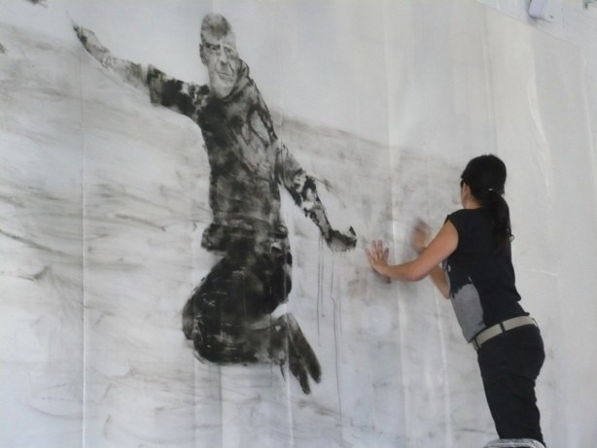

“Heart thinkers”, 2009_Work on progress Installation Gruut, Gent

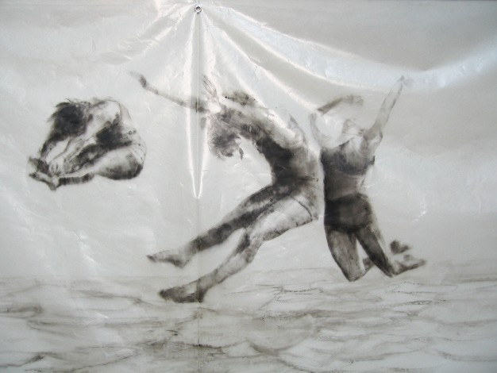

“Over the ocean I”, 2007 _ 180 x 300 cm _ Acryl on plastic

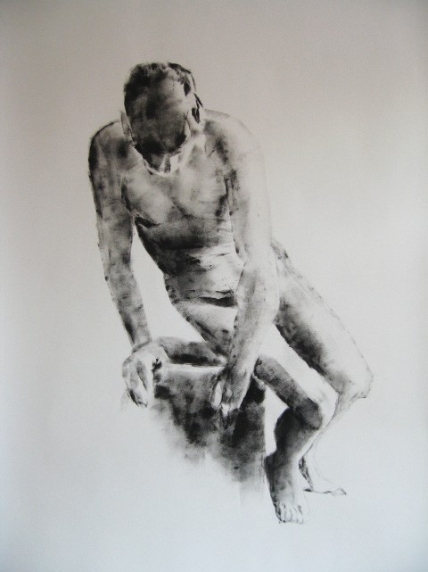

“Pedes in terra ad sidera visum”, 2007 _ 270 x 150 cm _ Acryl on paper

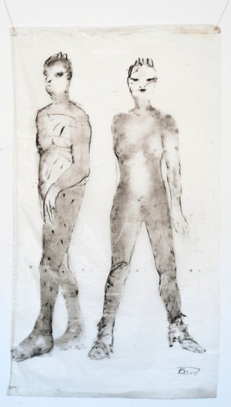

“Woman and man”, 2003_ 205 x 115 cm _ Acryl on plastic

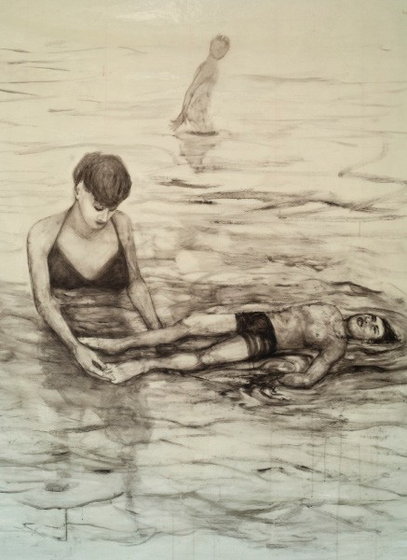
“Untitled”, 2008_ 150 x 200 cm _ Acryl on plastic

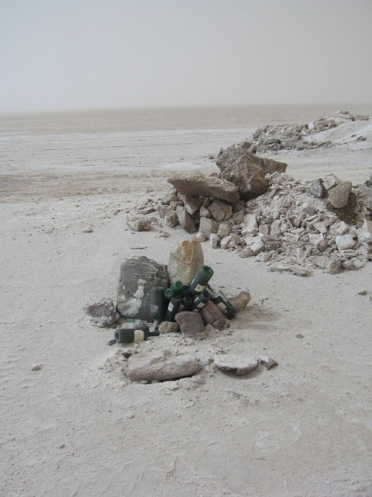

“Swimming pool and Apacheta”, 2009 _ 80 x 60 cm
_ Photograph on dibond

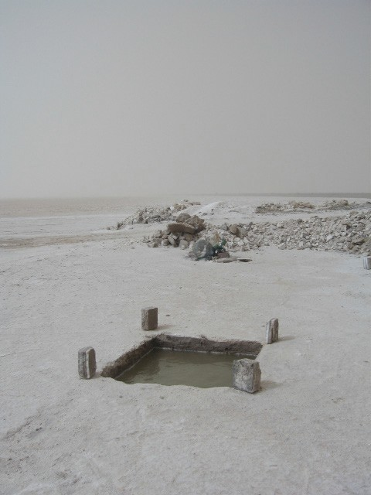

“Apacheta”, 2009 _ 80 x 60 cm
_ Photograph on dibond

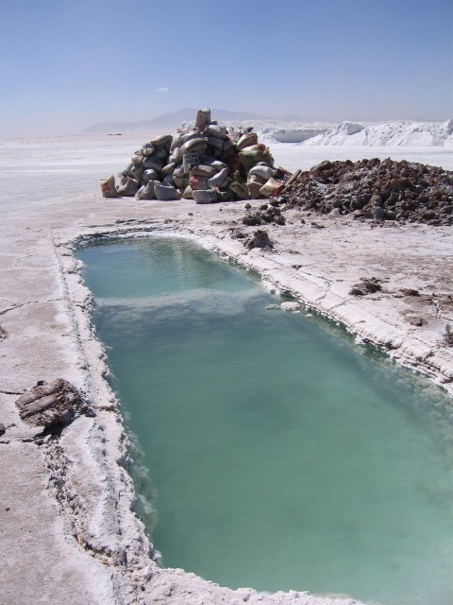
“Swimming pool”, 2007 _ 80 x 60 cm _ Photograph on dibond

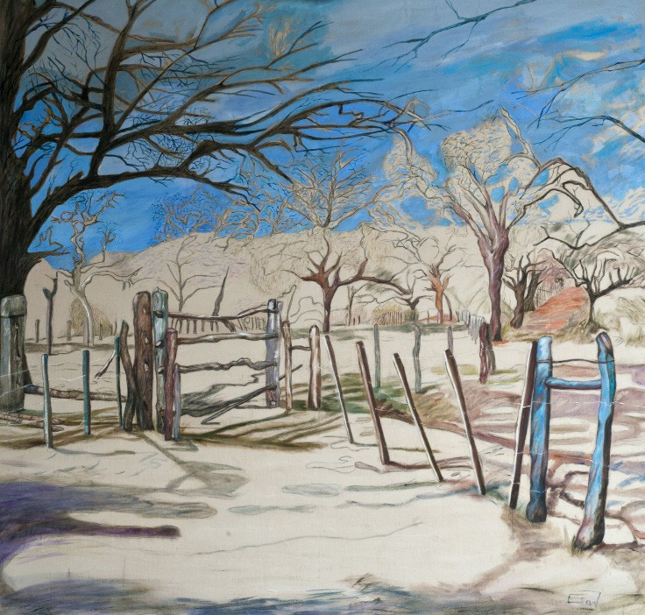

“Sury Micuna”, 2010 _ 200 x 210 cm _ Oil on canvas

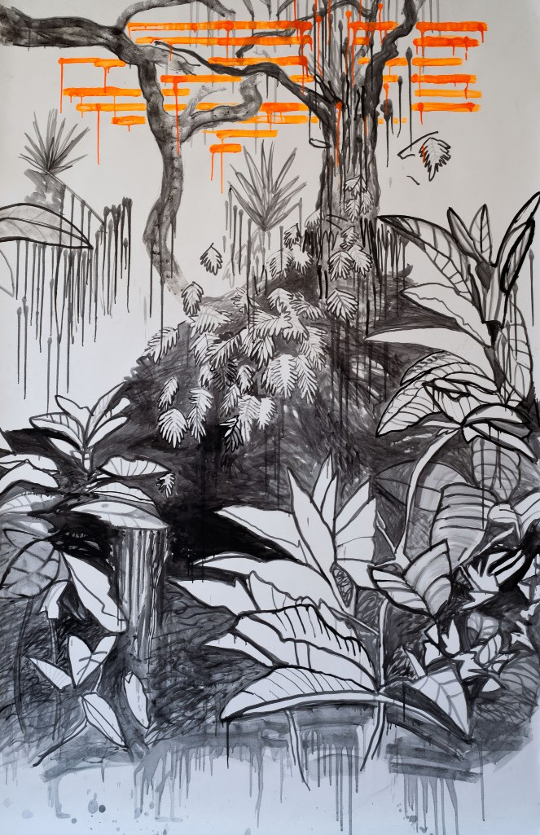

“Selva Tucumana”, 2010 _ 225 x 150 cm _ Drawing with ink on paper_ Private Colllection.

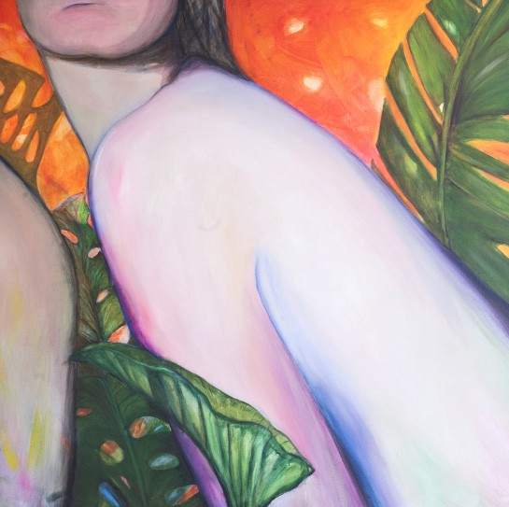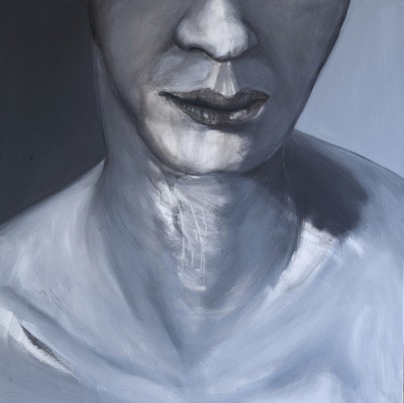

“Woman”, 2001 _ 150 x 150 cm _ Acryl on canvas “Woman”, 2001 _ 150 x 150 cm _ Acryl on canvas

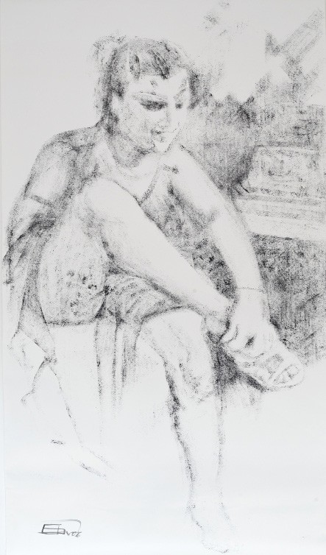

“Woman”, 2010 _ 150 x 250 cm _ Acryl on paper_Private collection_

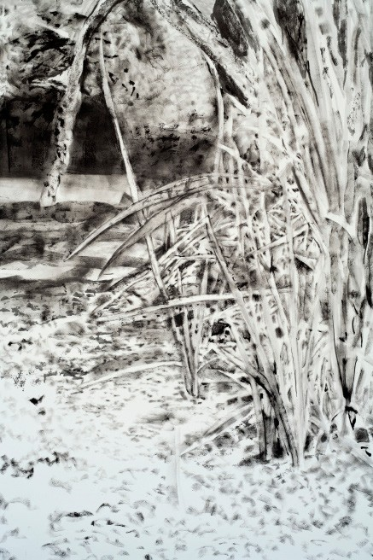

“Park El Rey”, 2010_ 150 x 250 cm _ Drawing with ink on paper_Private Collection_

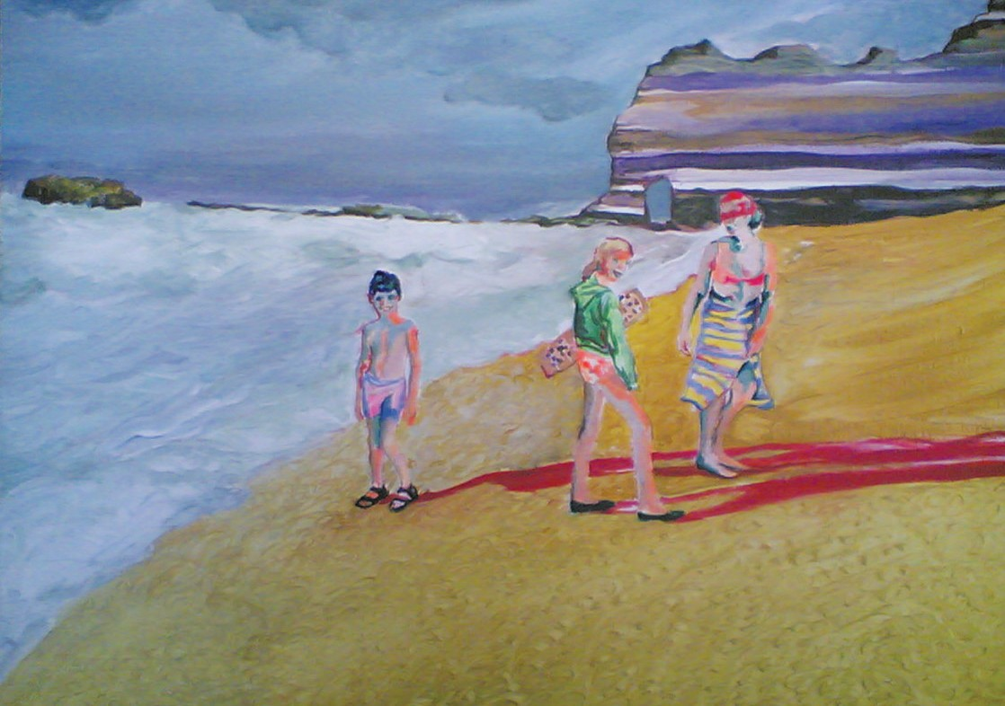
“Summer 2004”, 2004 _ 40 x 60 cm _ Oil on canvas

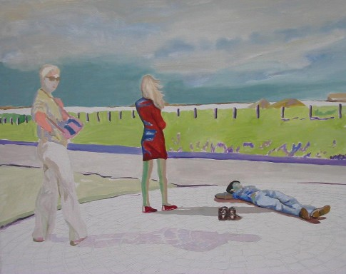
“Trough the time”, 2004 _ 40 x 60 cm _ Oil on canvas

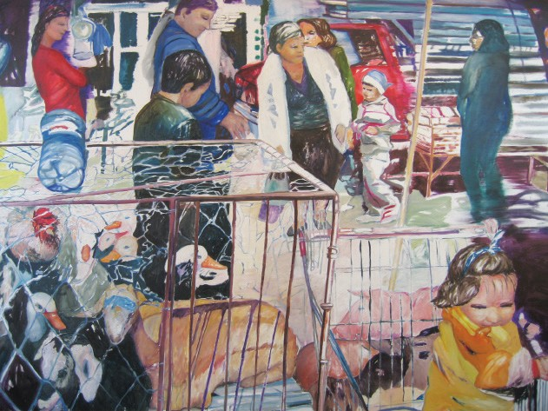
“Shopping in LA”, 2007 _ 200 x 200 cm _ Oil on canvas

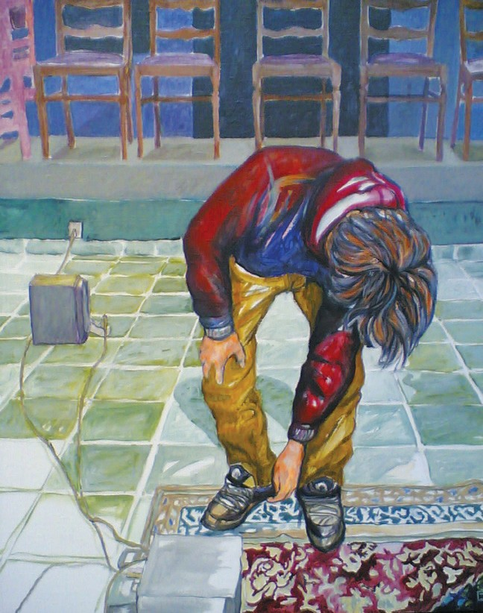
“Michiel”, 2009 _ 60 x 50 cm _ Acryl on canvas

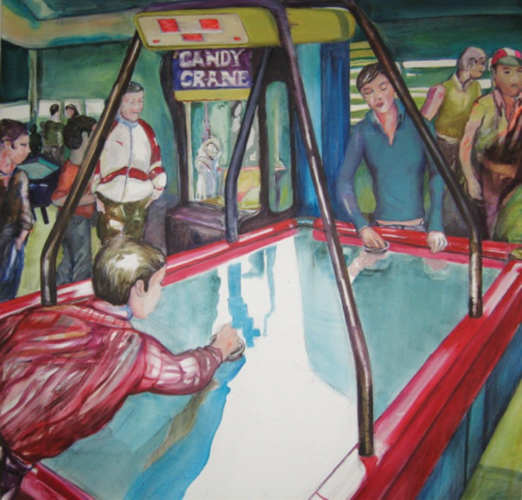

”Games”, 2009 _ 140 x 140 cm _ Acryl on canvas

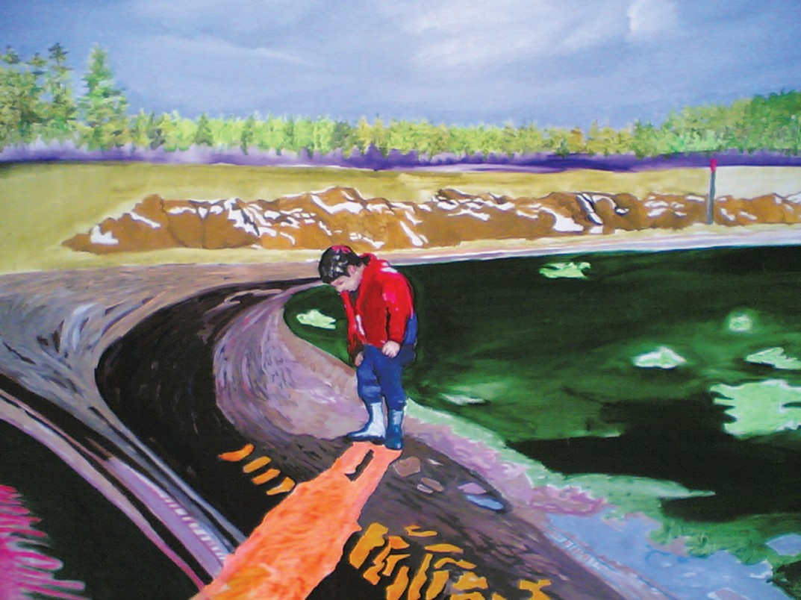

“The day I saw you”, 2010 _ 100 x 120 cm _ Acryl on canvas

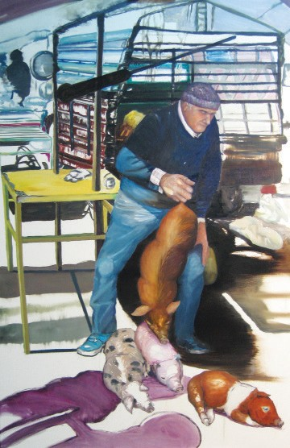
“Markt”, 2009 _ 151,5 x 99,5 cm _ Oil on canvas

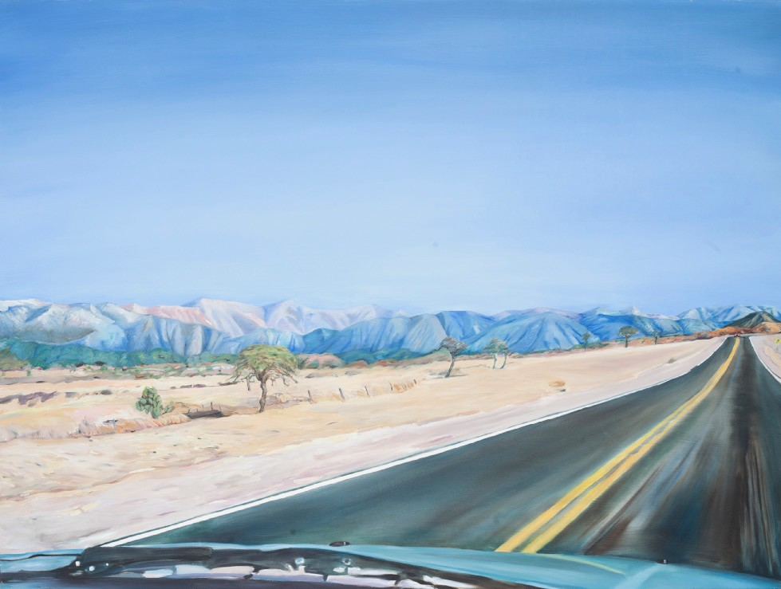

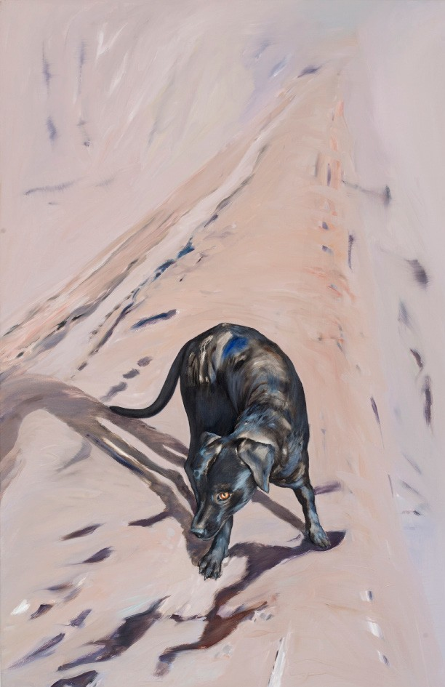“Who knows where time goes”, 2008 _ 120 x 150 cm _ Oil on canvas

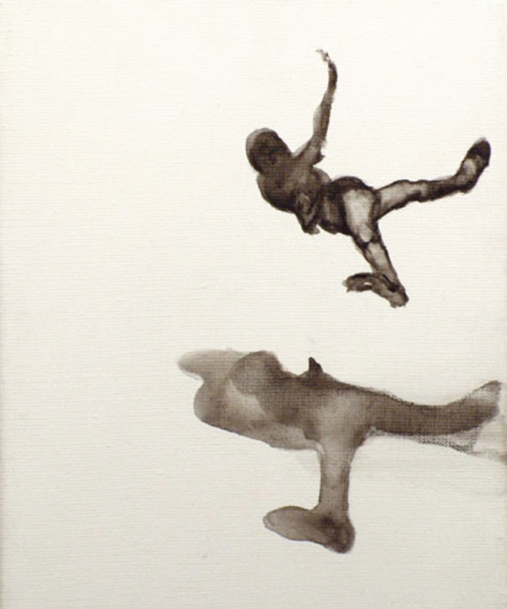

“Salto from the serie shadows”, 2001 _ 24 x 30 cm
_ Acryl on canvas

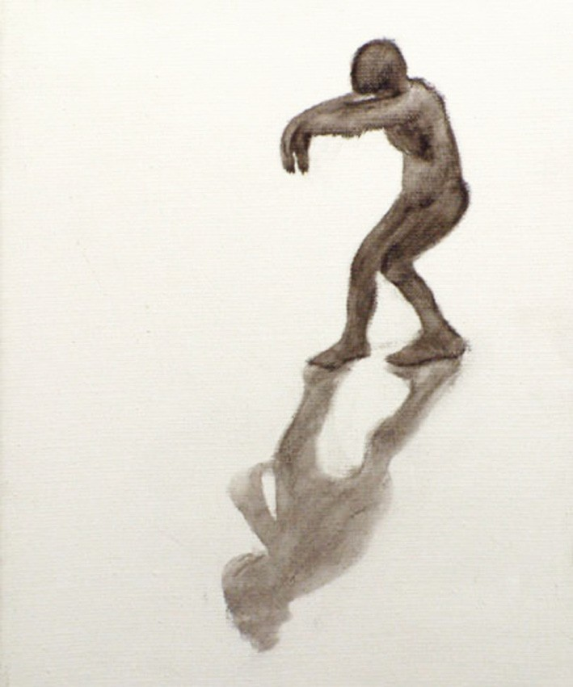

“The Sleepwalker”, 2001 _ 24 x 30 cm
_ Acryl on canvas

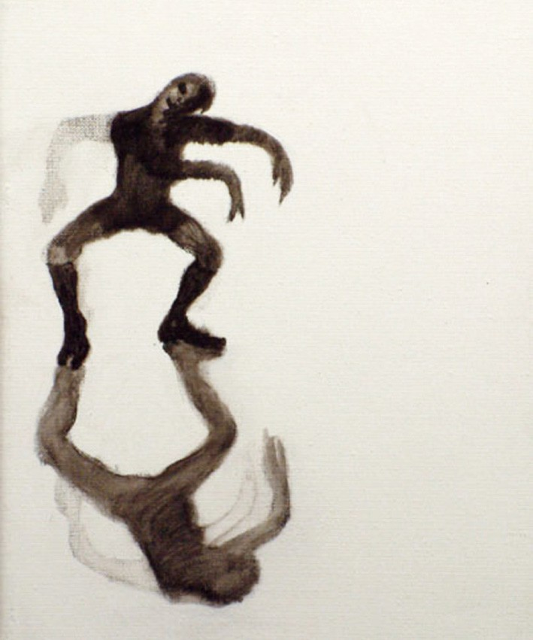

“Dancer”, 2001 _ 24 x 30 cm _ Acryl on canvas

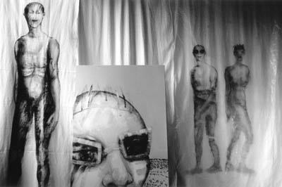

Installation “From the labyrinth of impressions”, 1997 _ Acryl on canvas and acryl on plastic

“Woman and man”, 2003_ 205 x 115 cm _ Acryl on plastic

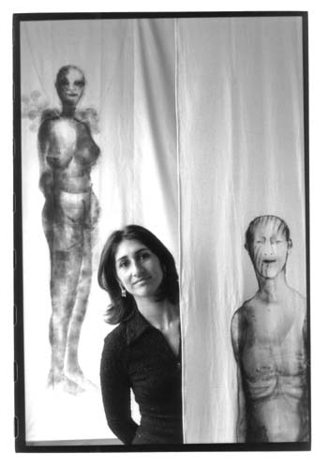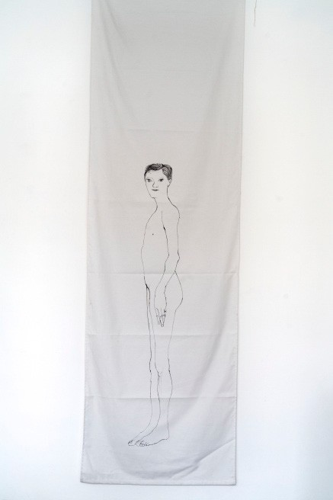
Installation “From the labyrinth of impressions”, 1997 _ Printing ink on cotton “Woman (white)”, 1996 _ 150 x 70 cm _Printing ink on cotton

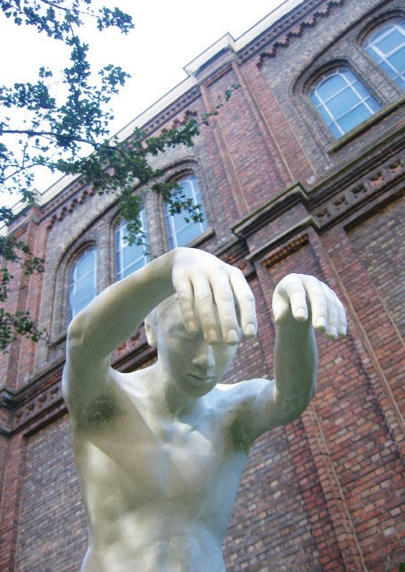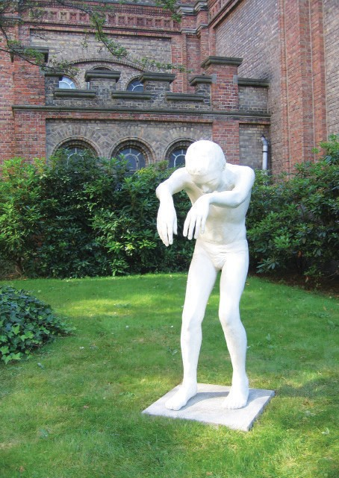

Installation Museum Dr.Guislain, Gent
“The Sleepwalker”, 2009 _ 120 x 40 x 70 cm _ Marble epoxy, Ed. 6 + 2
Installation Museum Dr.Guislain, Gent
“The Sleepwalker”, 2009 _ 120 x 40 x 70 cm _ Marble epoxy, Ed. 6 + 2

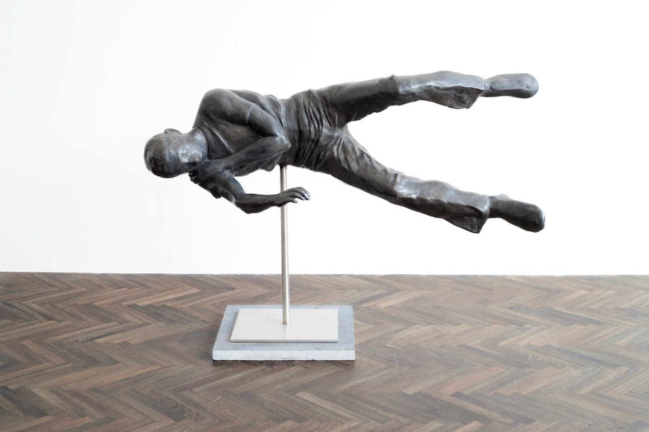

“Falling man II”, 2013 _ 71 x 30 x 30 cm _ Bronze, Ed. 6 + 2 _

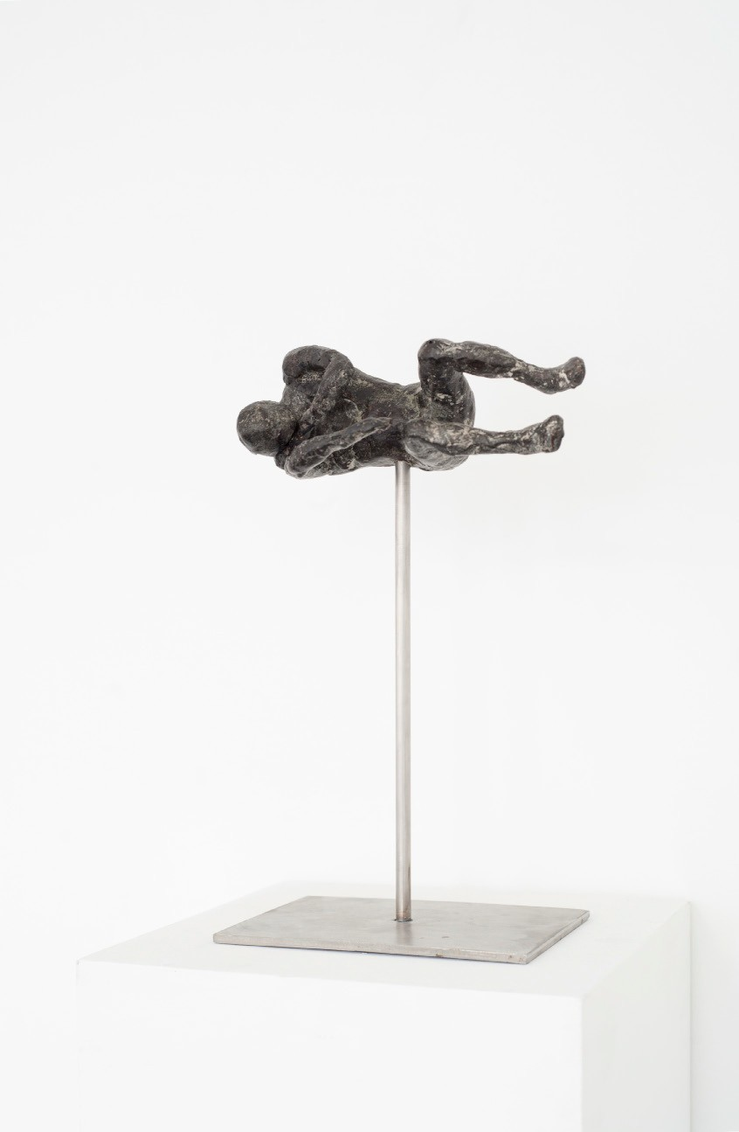
“Falling man”, 2013 _ 20 x 10 x 9 cm _ Bronze, Piéce unique

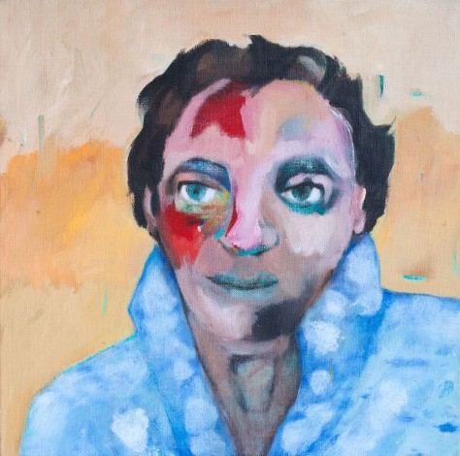

“Memorias de ella”, 1997_ 40 x 40 cm
_Acryl on canvas

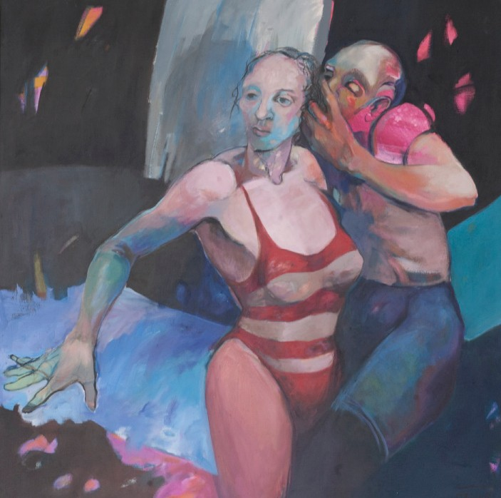
“Arrebato renacetista”, 1988_ 100 x 100 cm _ Acryl on canvas

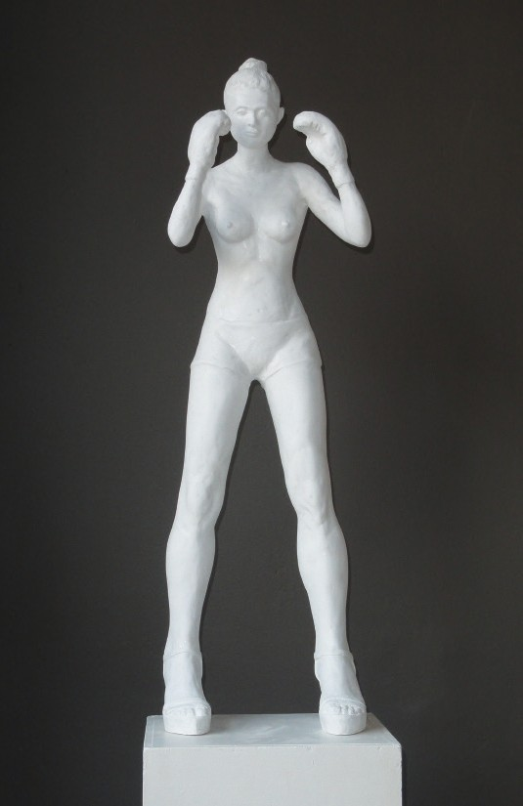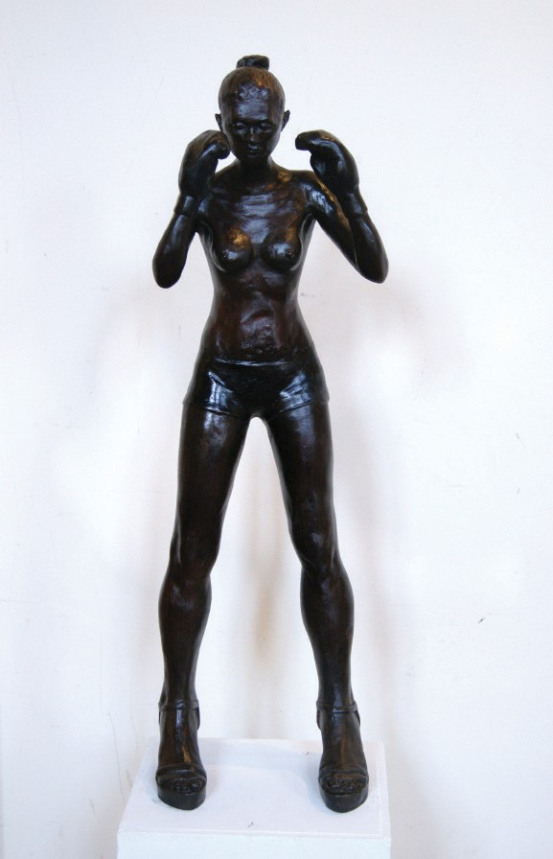

“High heels”, 2013_ 90 x 40 x 50 cm _ White polyester “High heels”, 2012_ 90 x40 x50 cm_ Bronze_Private Collection Belgium

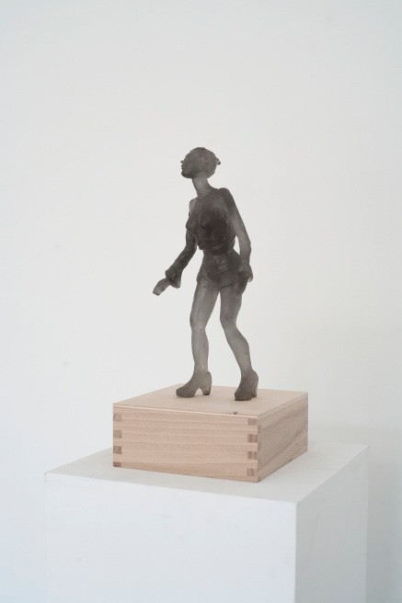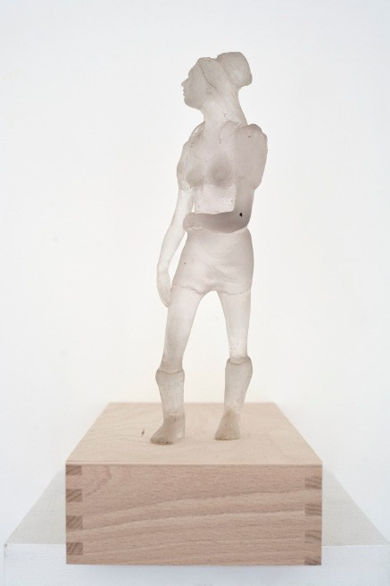

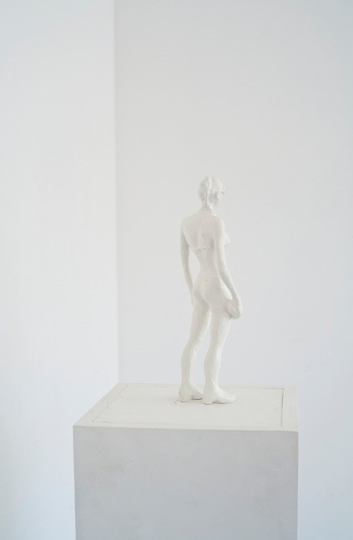“Untitled fille”, 2013_ 25 x 10 x 12 cm
_ Grey polyester, Ed. 6 + 2
“Untitled fille”, 2013_ 25 x 10 x 12 cm
_ Trasparent polyester, Ed. 6 + 2

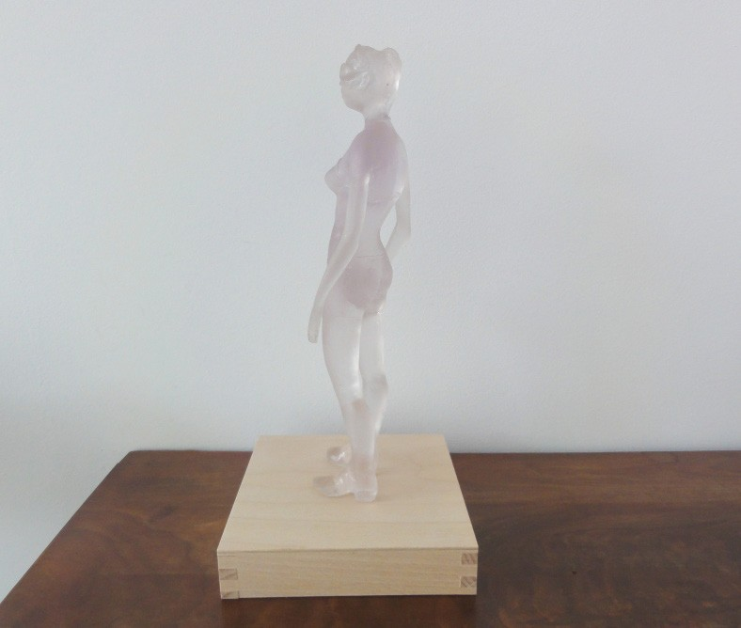

“Untitled fille”, 2013_ 25 x 10 x 12 cm _ Trasparent polyester, Ed. 6 + 2
“Untitled fille”, 2013_ 29 x 10,5 x 6 cm _ Bronze & white powder coating, Private CollectionGermany

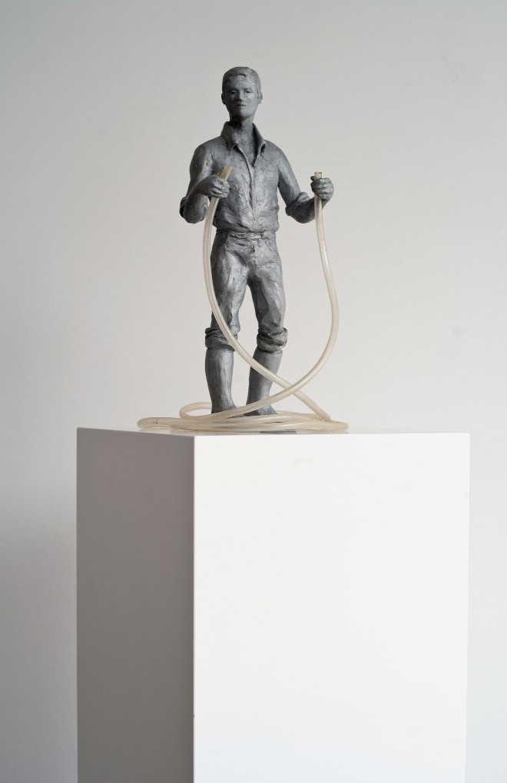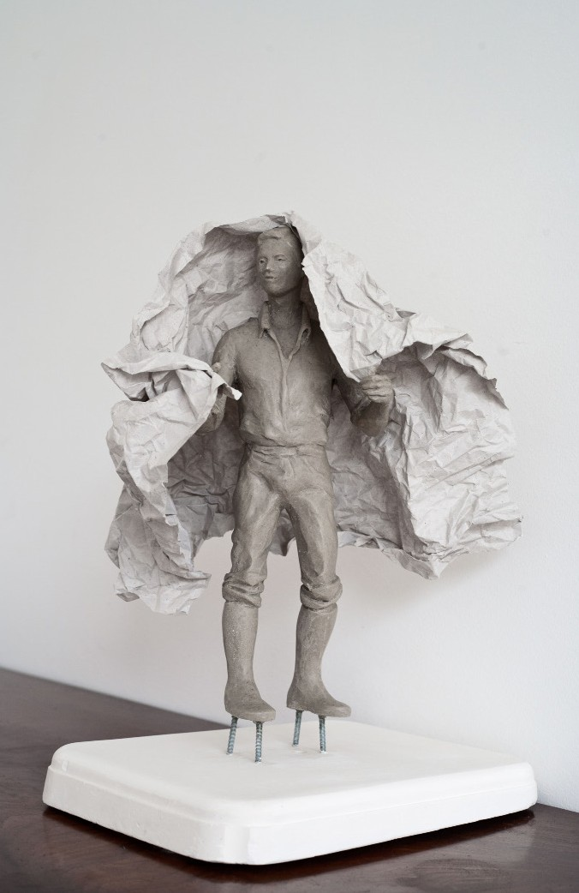
“The leveller”, 2013 _ 30,5 x 15 x 17 cm _ Silver polyurethane with rubber, Ed. 3 + 2 _Private Collection Belgium “Capeman met object 0,000301”, 2013 , in collaboration with Alice De Mont_ 27 x 19 x 40 cm
_ Polyurethane, plaster, paper

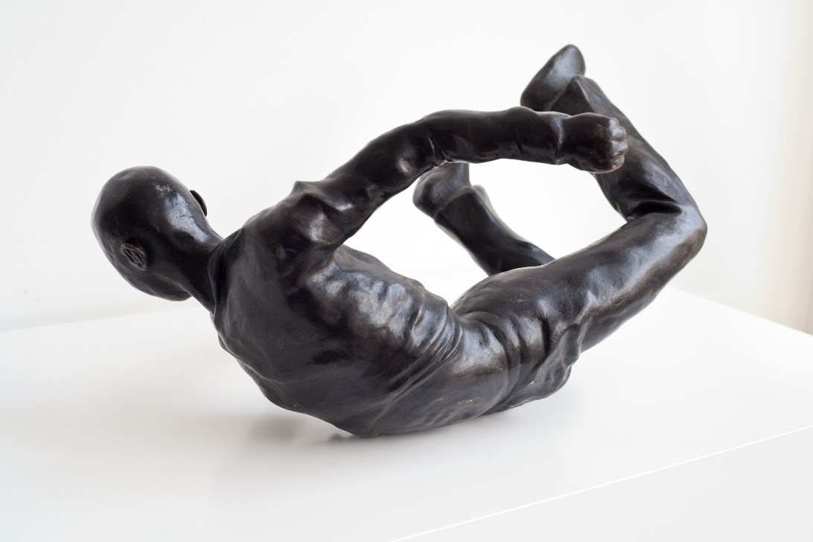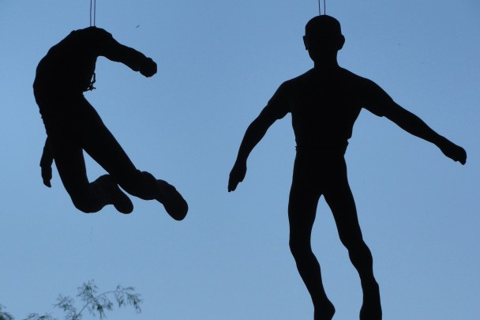

“Falling man III”, 2013 _ 52 x 42 x 46 cm _ Bronze, Ed. 6 + 2 _ “Falling man III”, 2013 / “Falling man I”, 2013 _ 52 x 42 x 46 cm / 77 x 55 x 17 cm
_ Patinated grey epoxy, Ed. 6 + 2

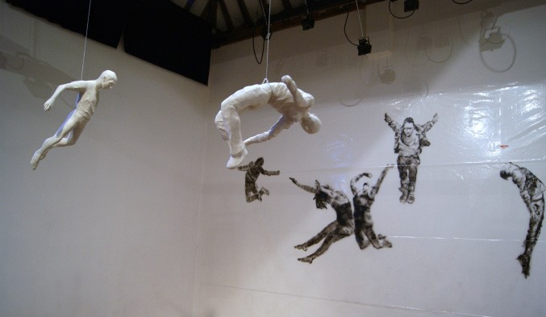
Installation Stills & Movements “Falling man I and III”, 2011 _ 52 x 42 x 46 cm _ Epoxy Background Acryl on plastic _View at Caermerkloster Gent, Belgium

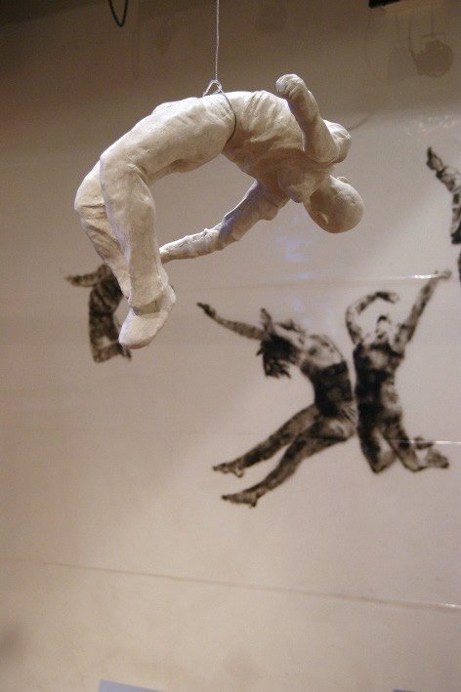
Installation Stills & Movements “Falling man III”, 2011 _ 52 x 42 x 46 cm
_ White Epoxy_ Background Acryl on plastic _ View at Caermerkloster Gent, Belgium

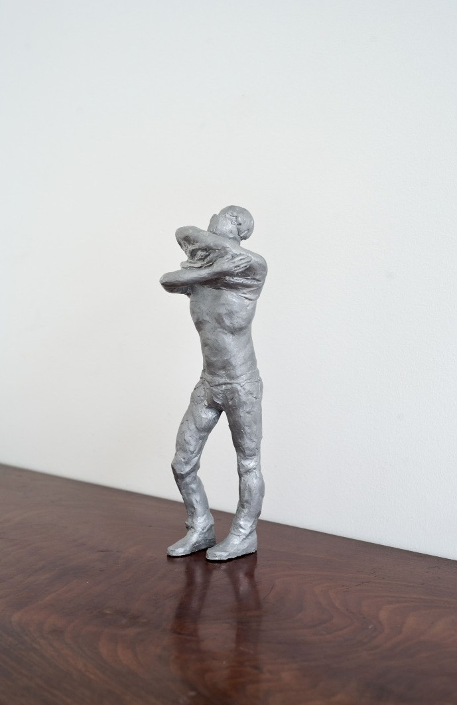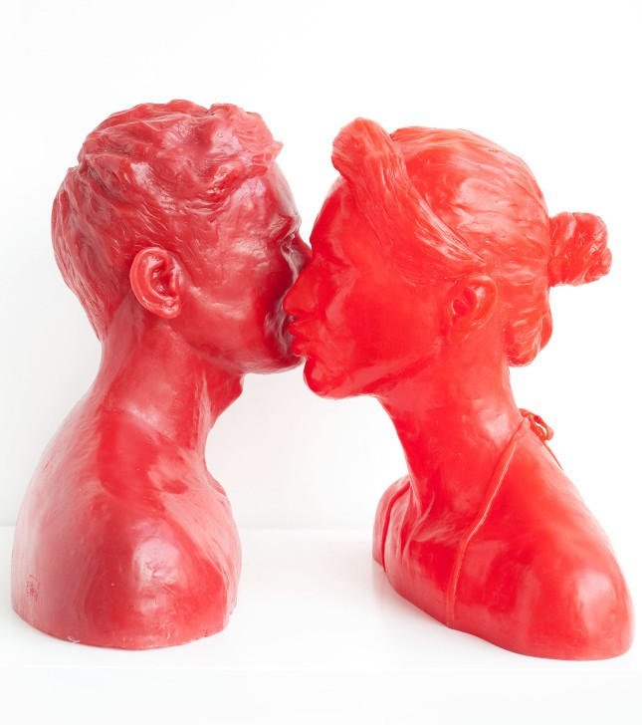

“The worker”, 2013 _ 29 x 9 x 8,5 cm _ Silver polyurethane “Face to face”, 2013 _ 46 x 27 x 45 cm (man) / 43 x 28 x 45 cm (woman) _ Red polyester

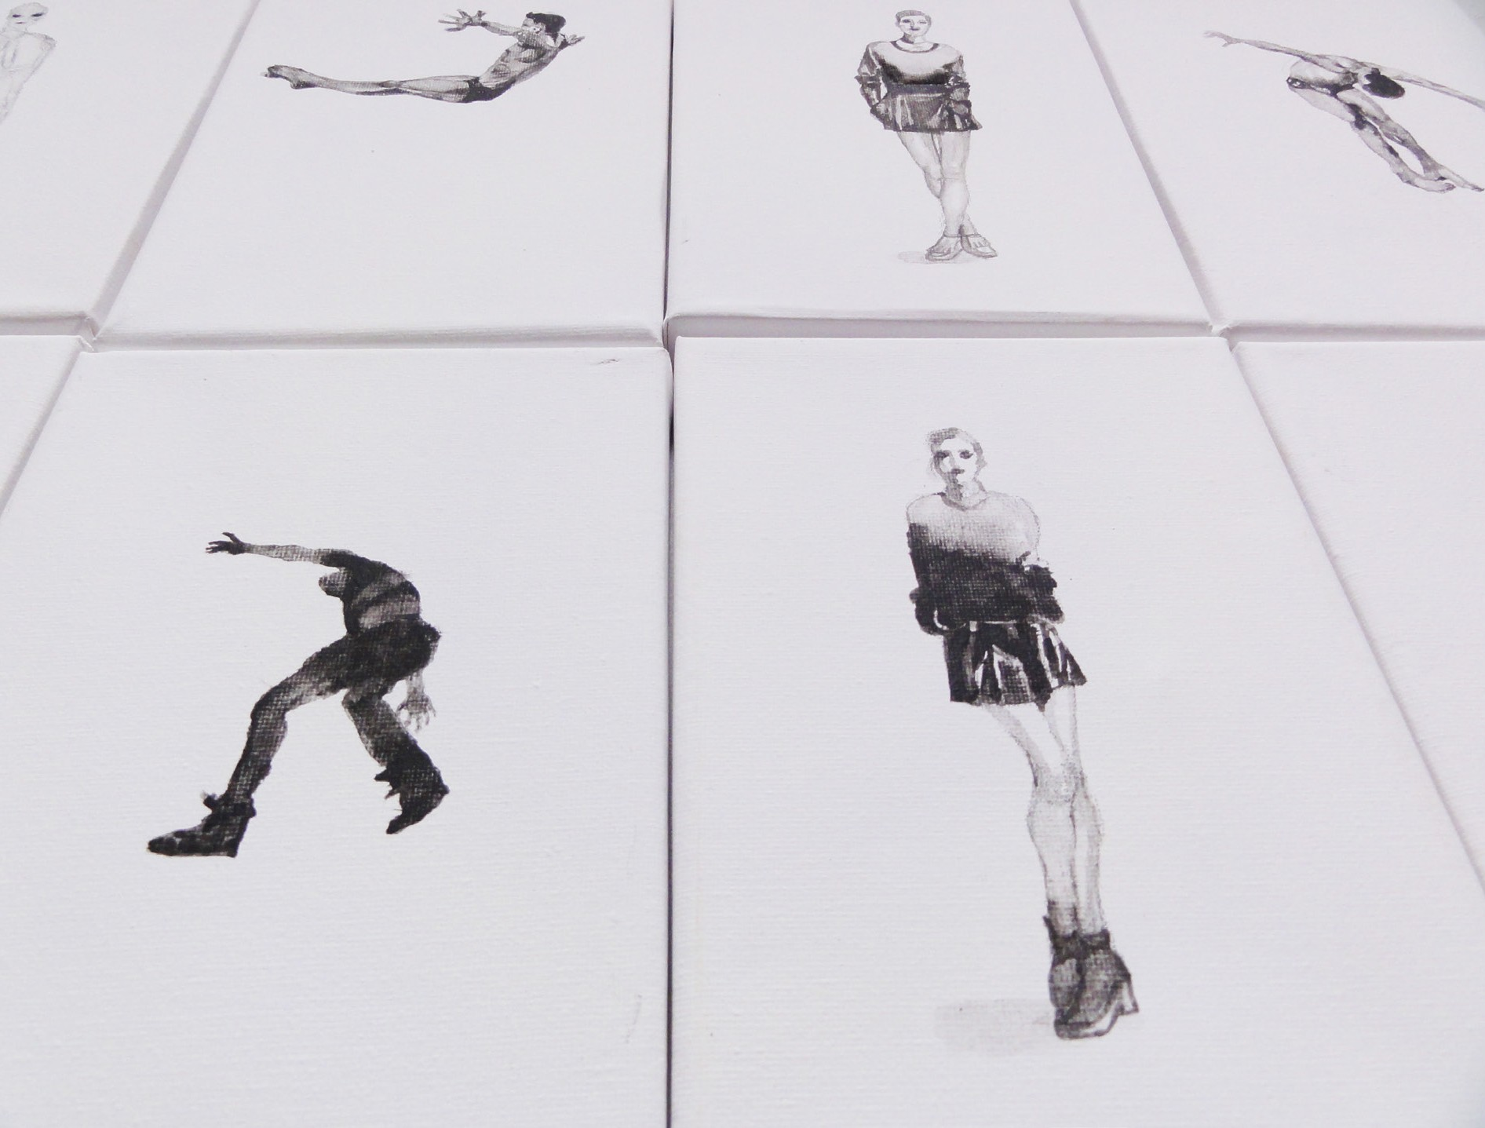
“Someone like you”, Serie for the exhibition at Hommes (Rotterdam), 2014 _ 13 x 18 cm
_ Acryl on canvas

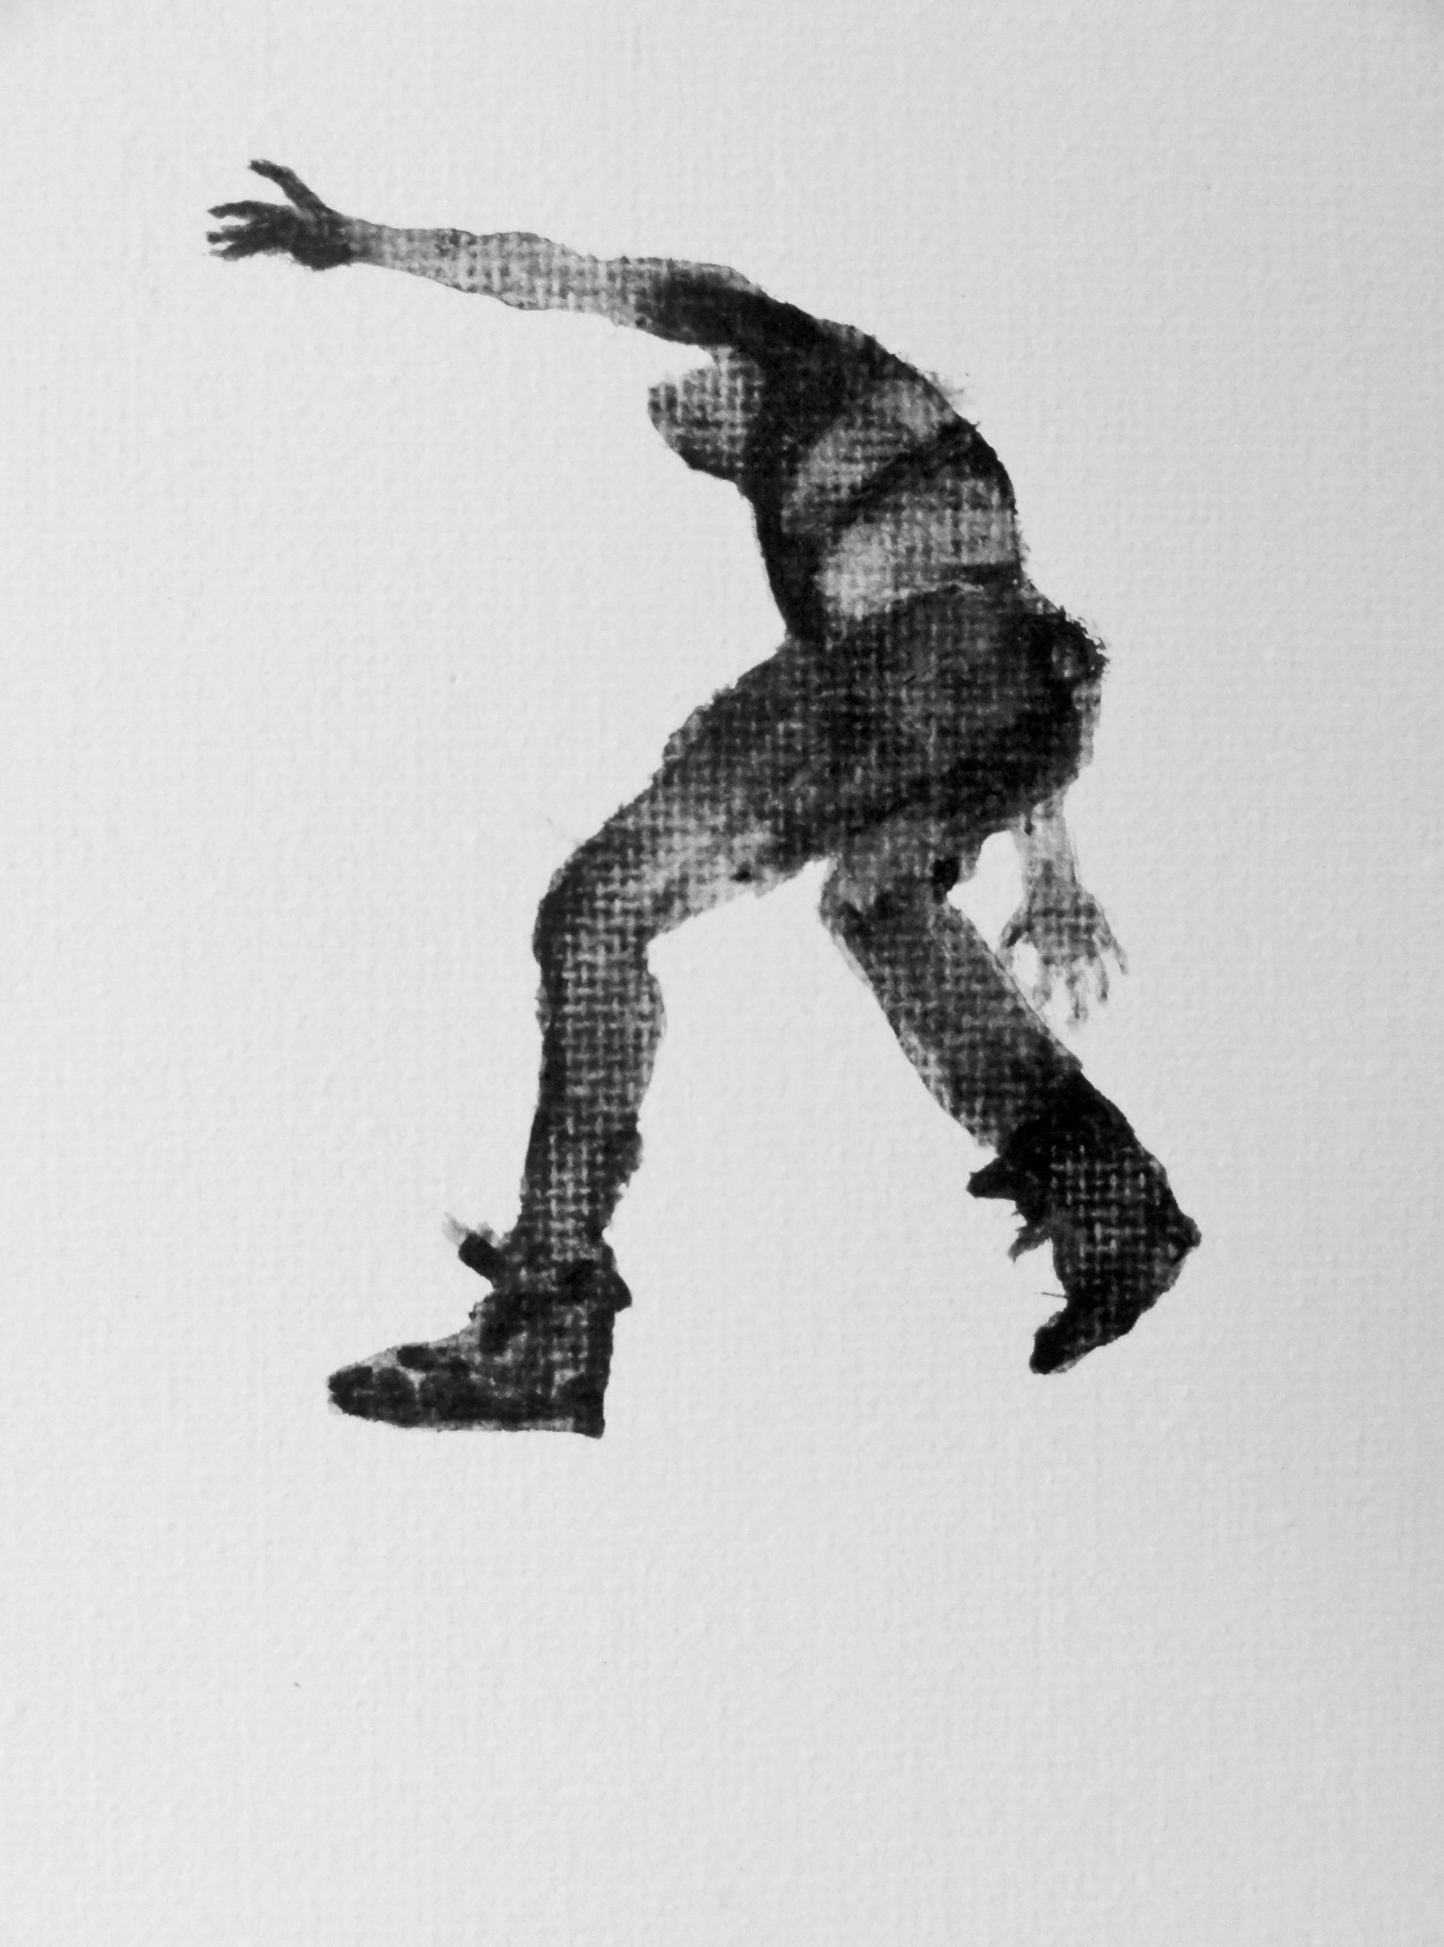

“Someone like you”, Serie for the exhibition at Hommes (Rotterdam), 2014 _ 13 x 18 cm
_ Acryl on canvas

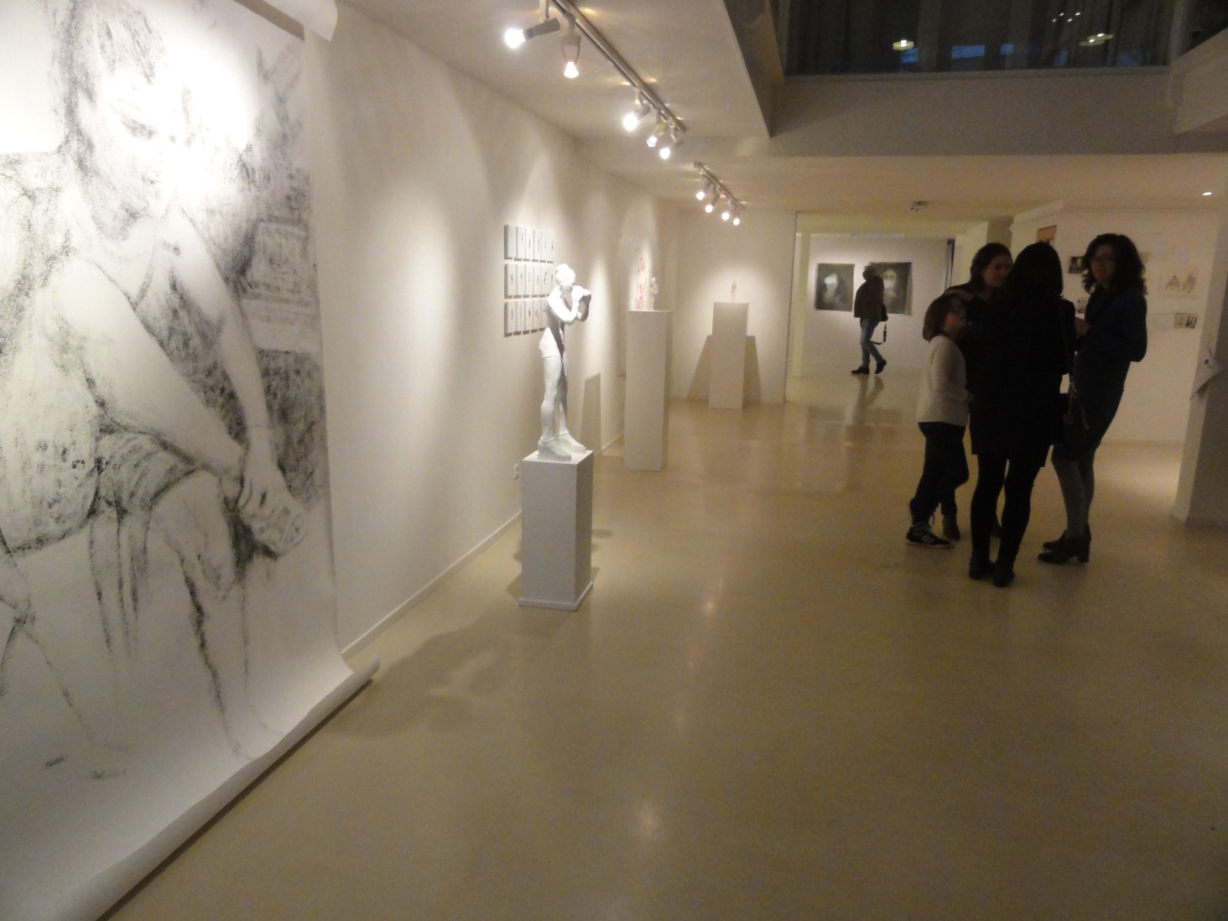

Installation view Hommes Galerie _ Rotterdam_

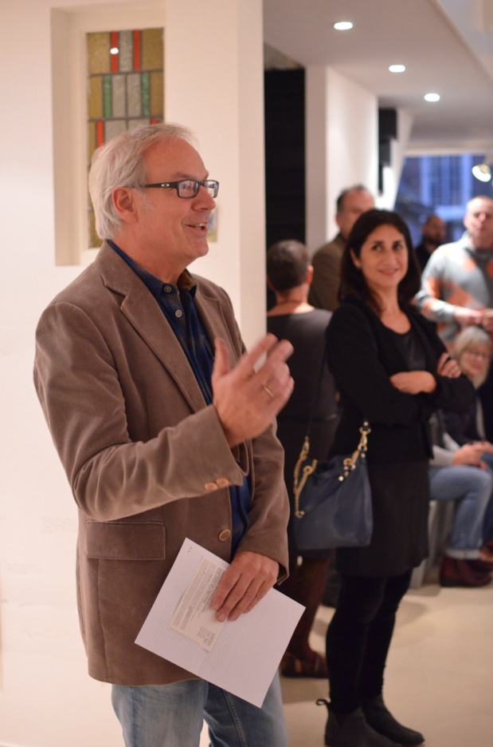

Hommes Galerie _ Rotterdam_ 2014

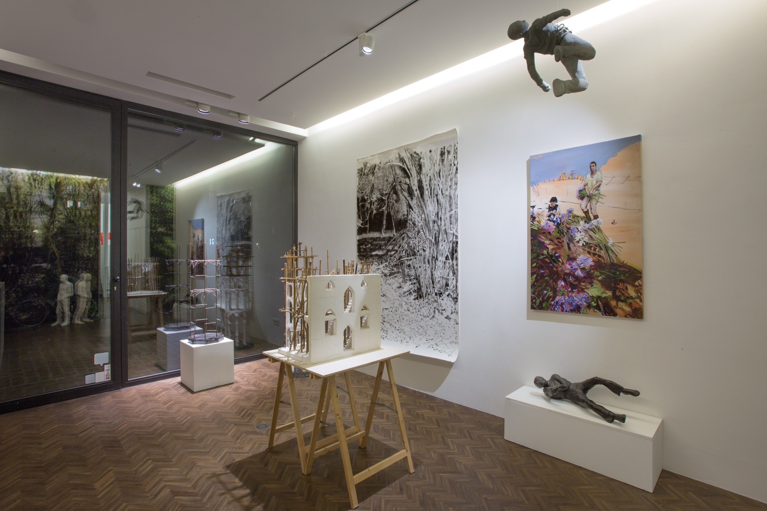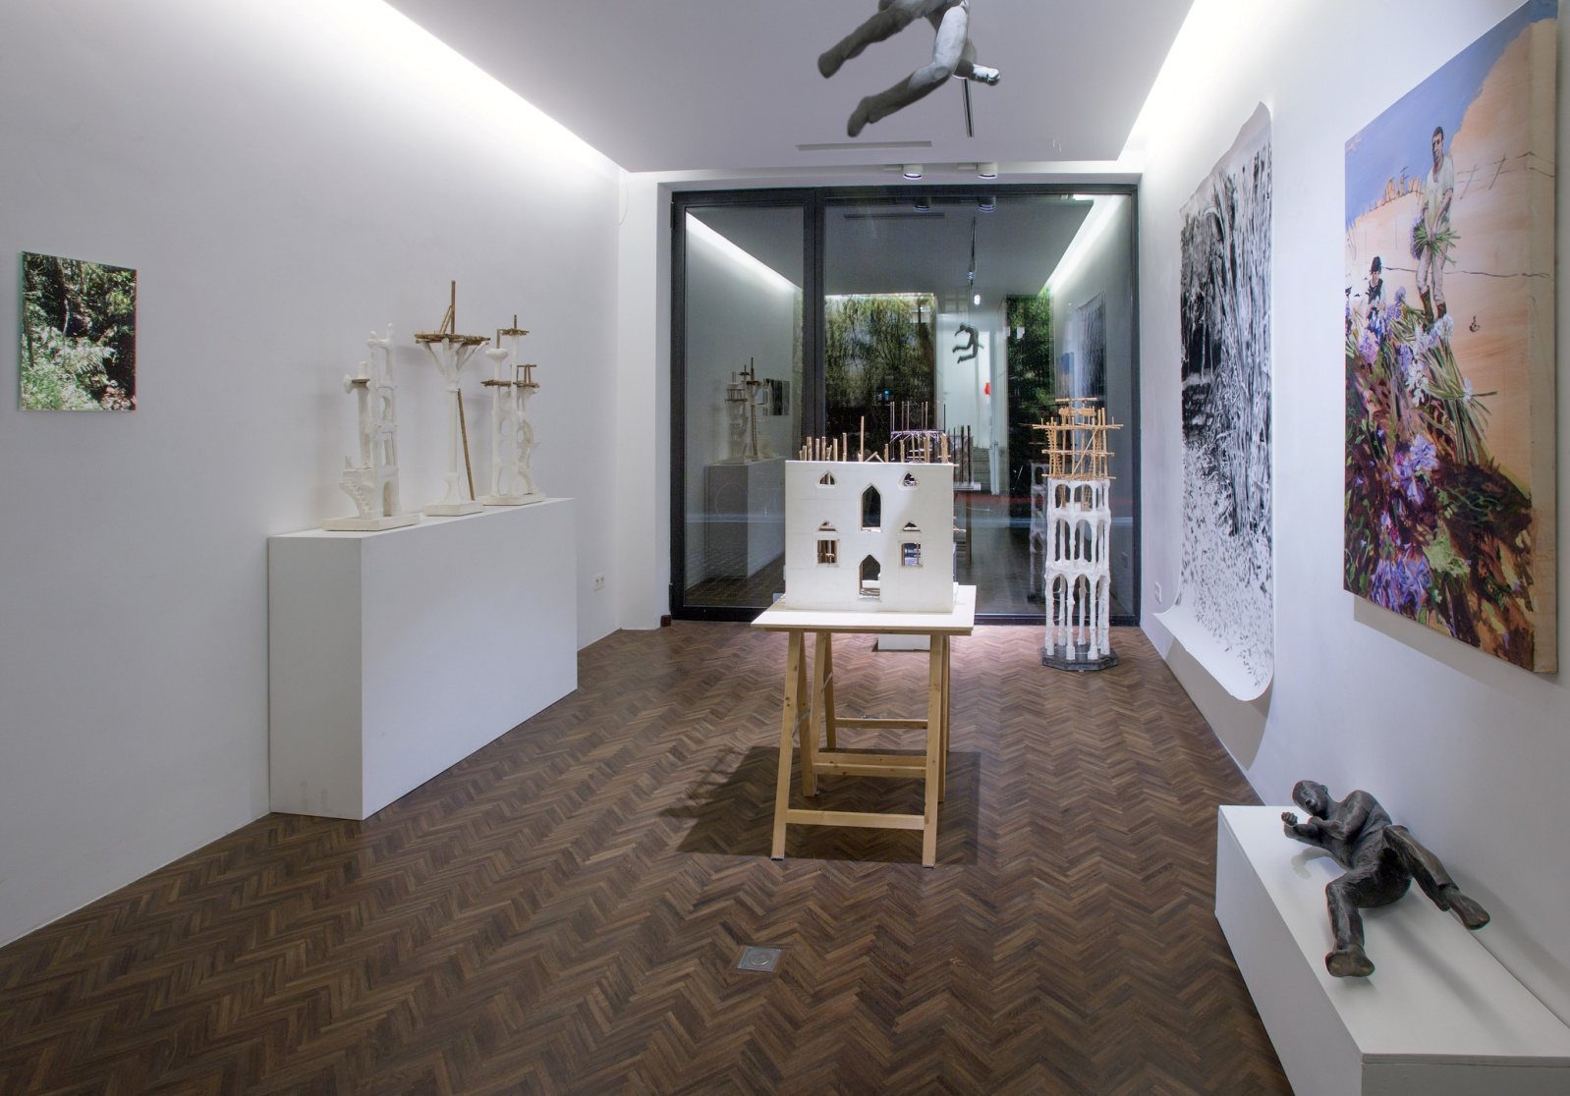

Installation view IMAGINE / DUO SHOW CECILIA JAIME & LUC ROGIEST _ 2015 _ Cecilia jaime Gallery _ Ghent

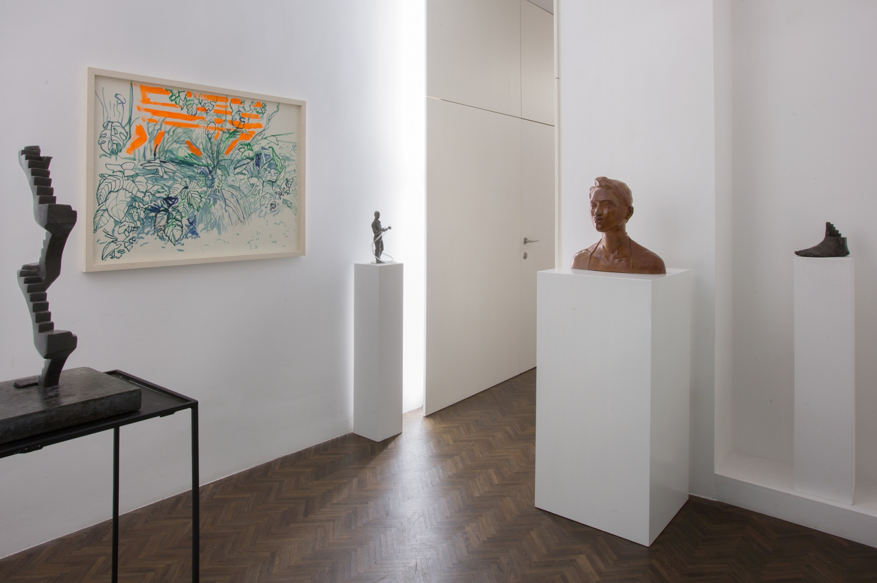

Duo Show IMAGINE _ Installation view _ 2015
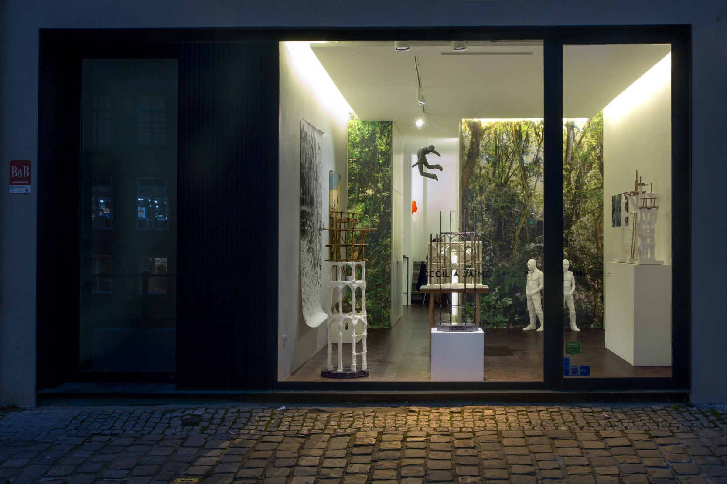

Duo show IMAGINE / Cecilia Jaime & Luc Rogiest

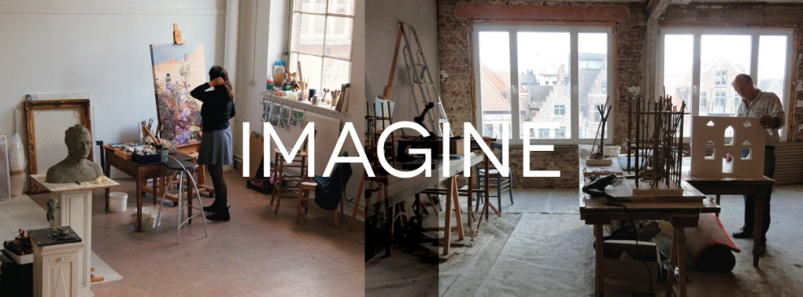

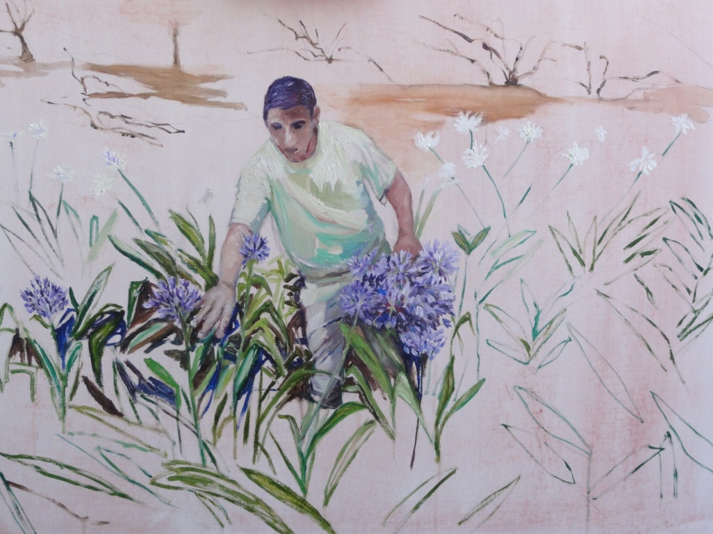

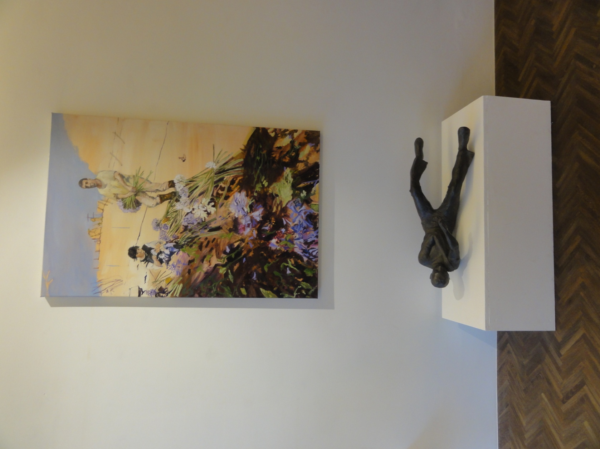

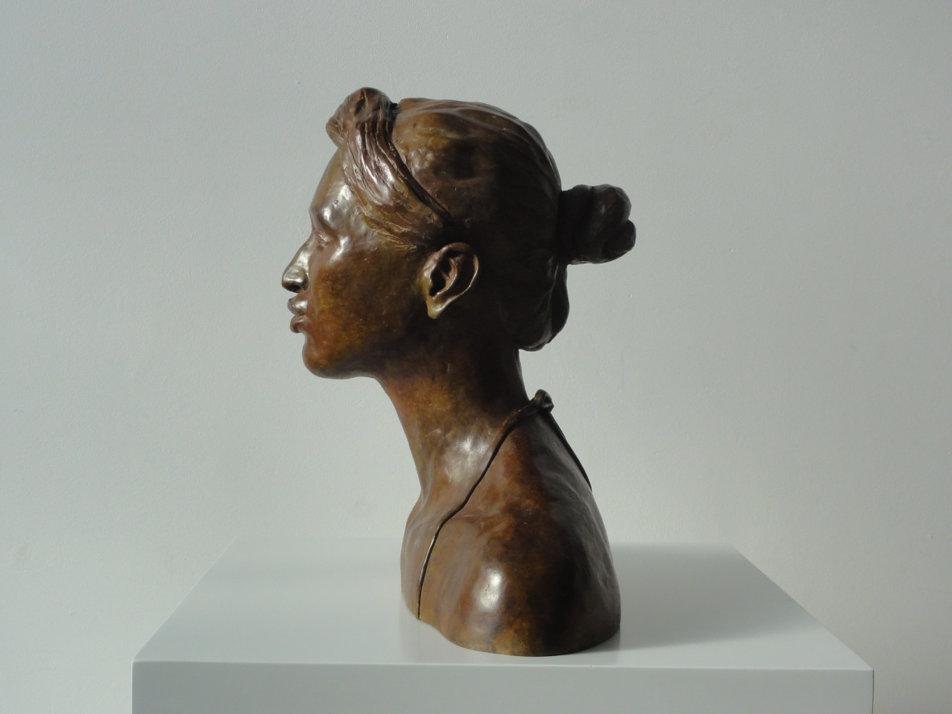

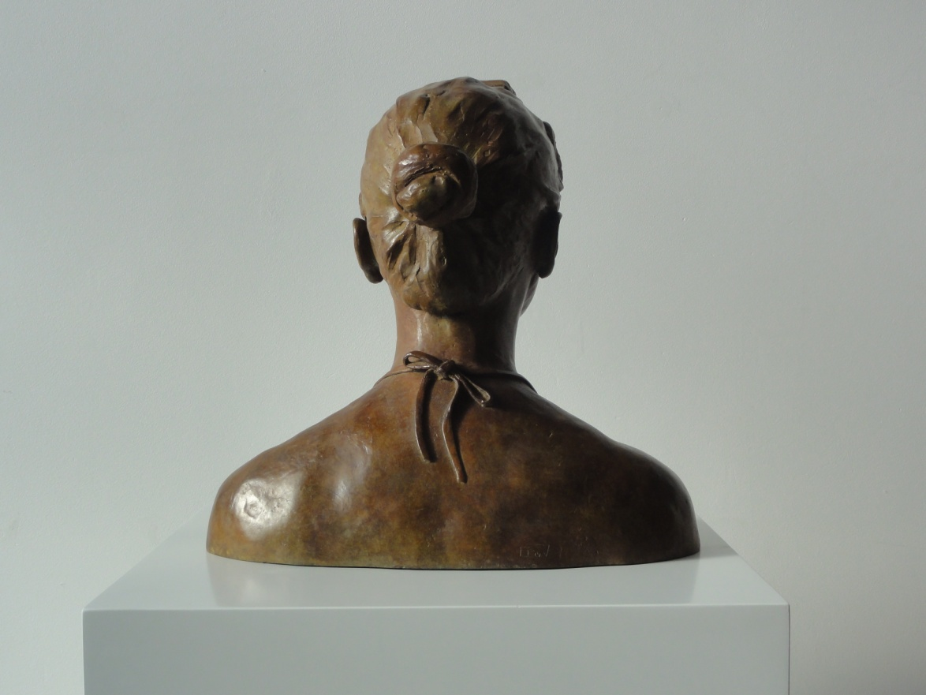

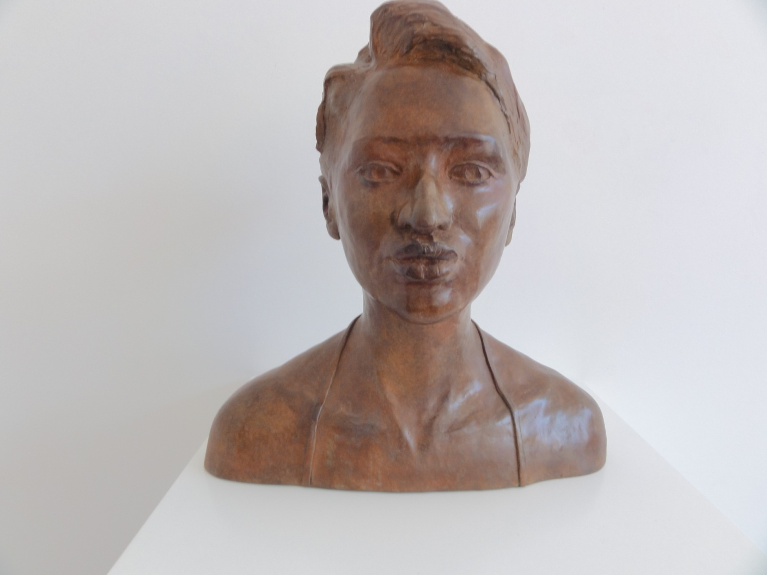

THE KISS_Bronce_48x28x45 cm_2015

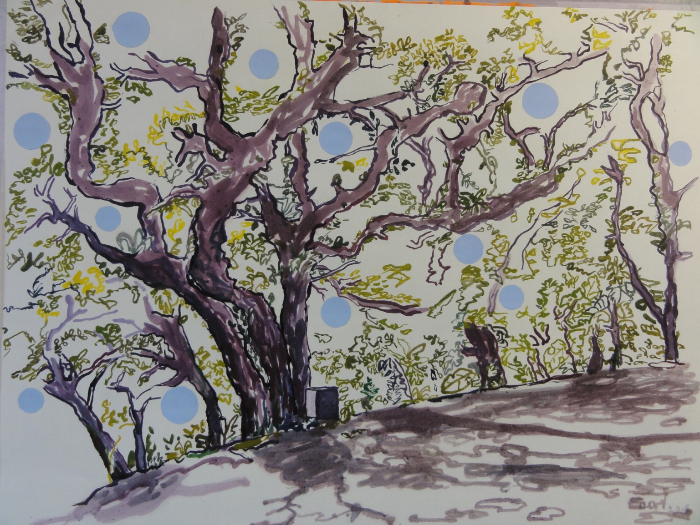
Blue bell Paradise_Ink on Paper_2016

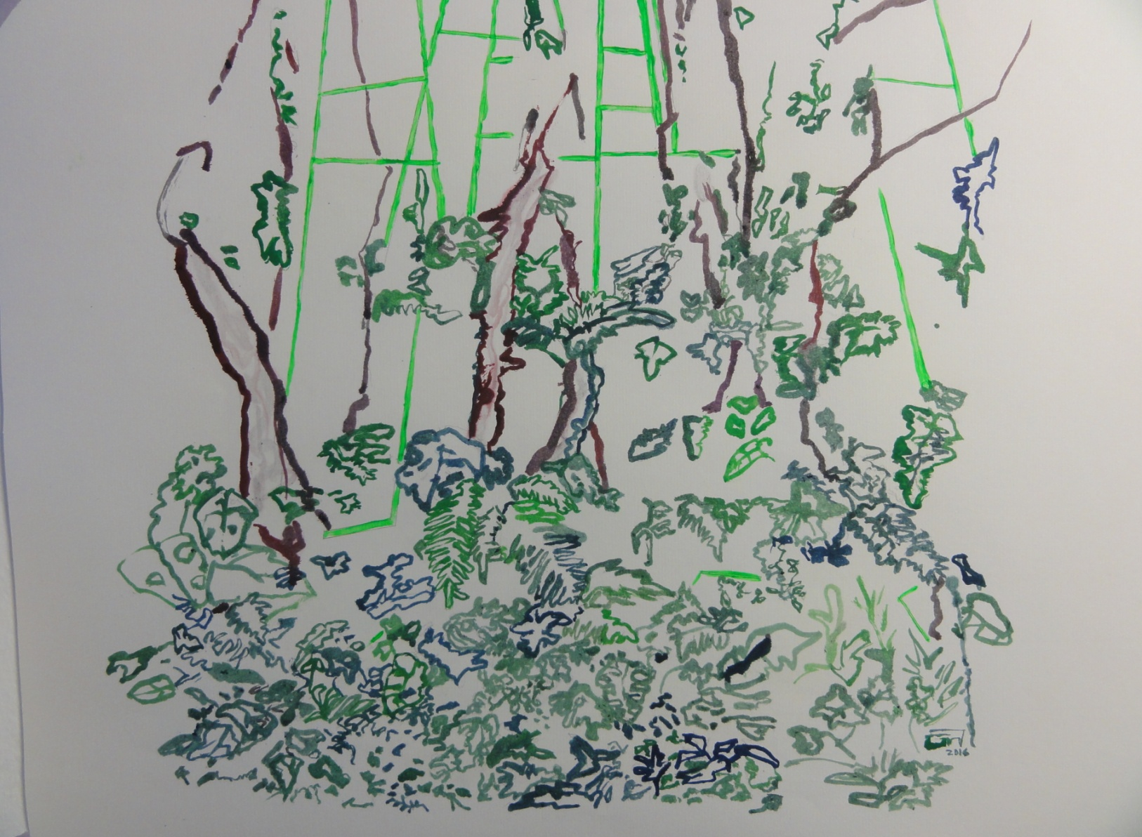

Jungle Border_2016_Ink on Paper

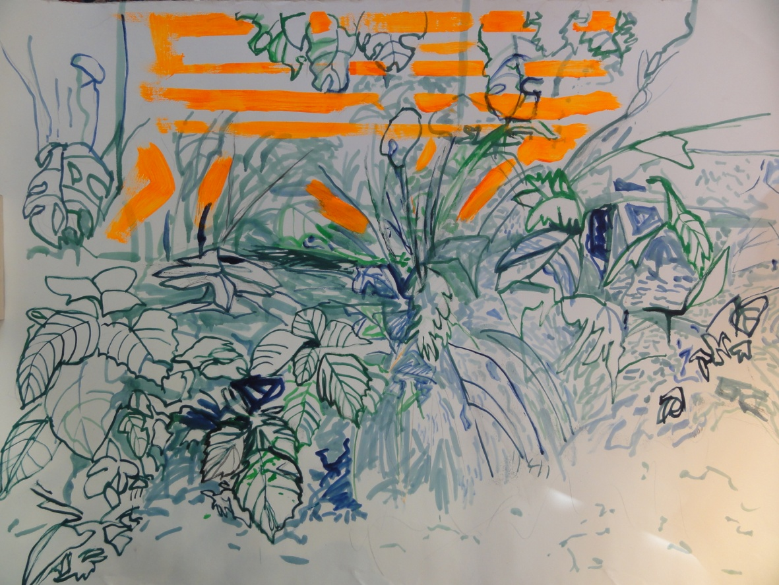

Jungle_ Ink on pape_ Framed with museum glass_2015

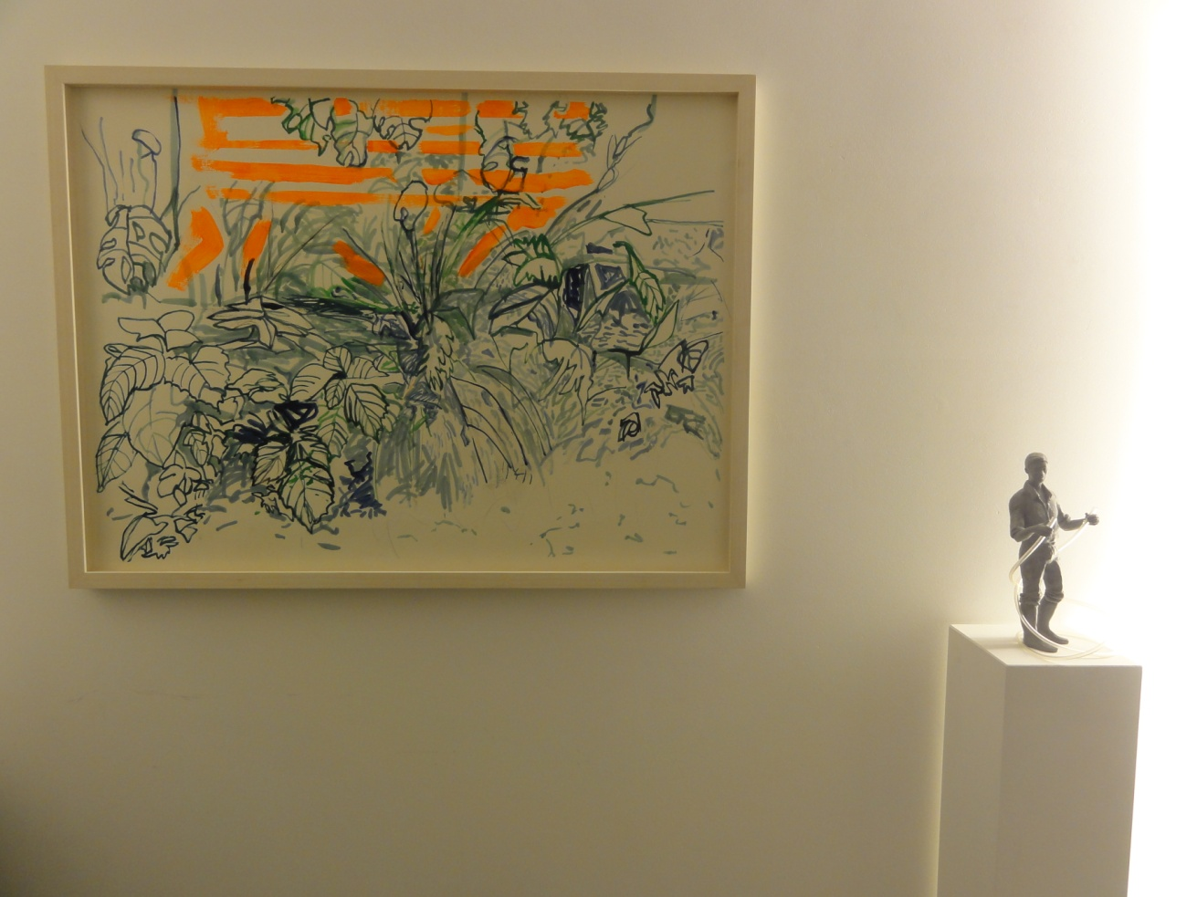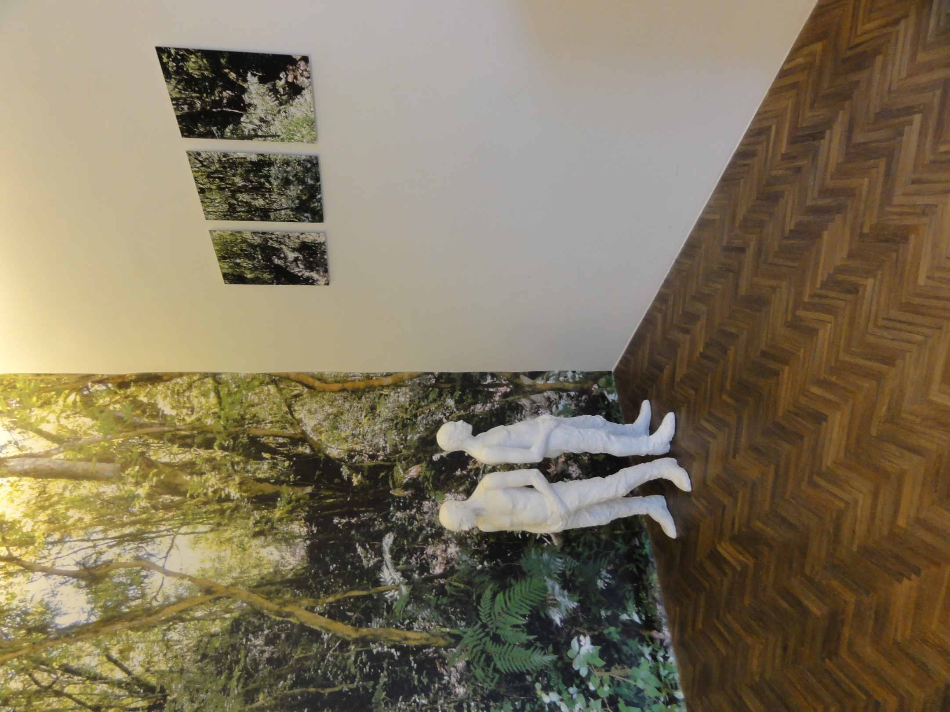
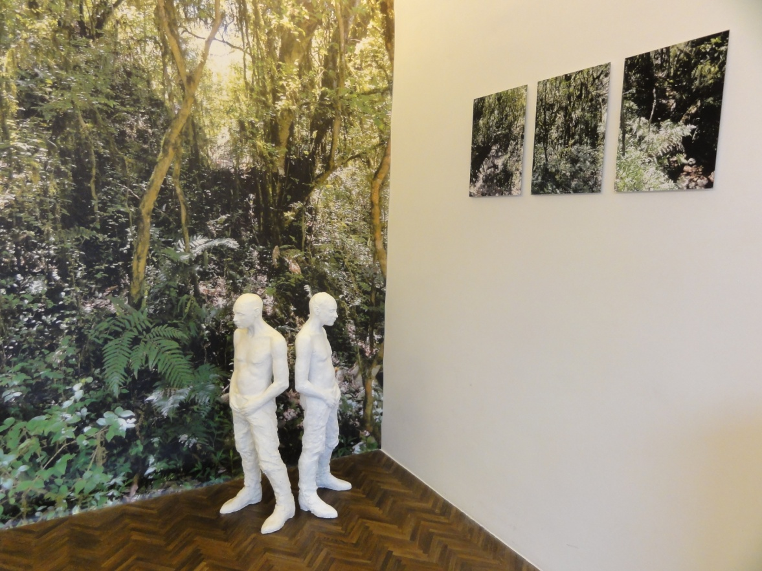

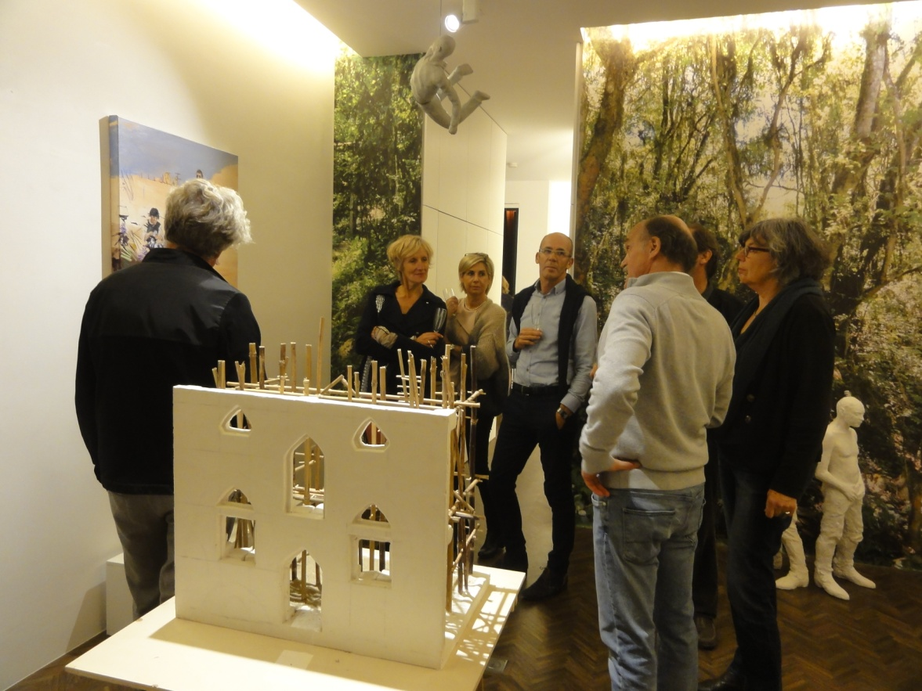

IMAGINE_2015_Mural photograph background_300cmx210cm_ & Men sculptures by Cecilia Jaime
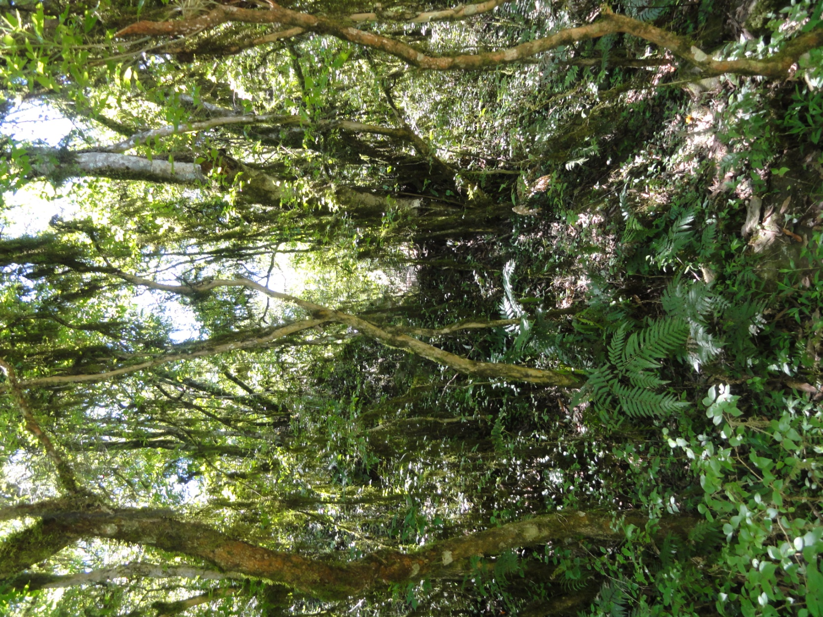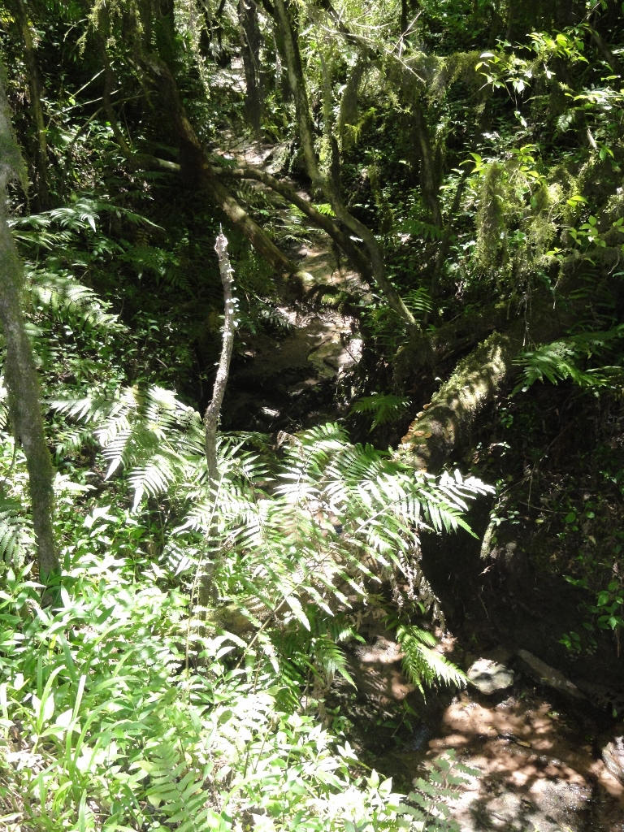

Jungle II_2015_Inject printed on dibond _Ed of 1/5_Photograph by Cecilia Jaime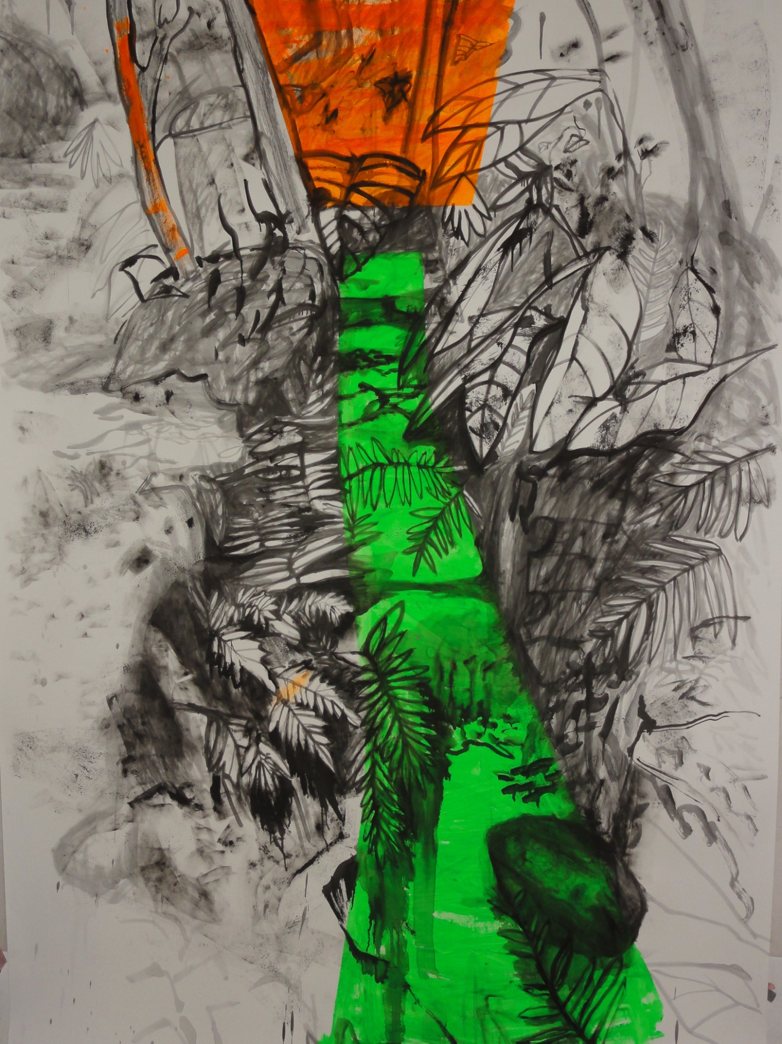

Jungle Drawing with ink and acryl on paper_250cm x150cm_

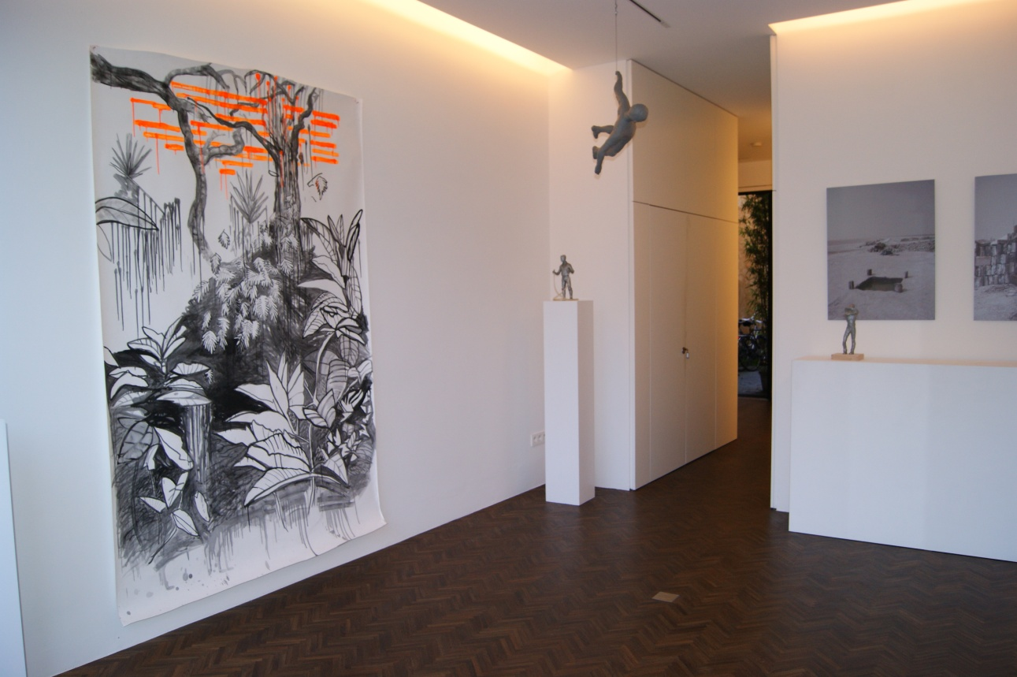

SOLO SHOW AT CECILIA JAIME GALLERY_ 2013_

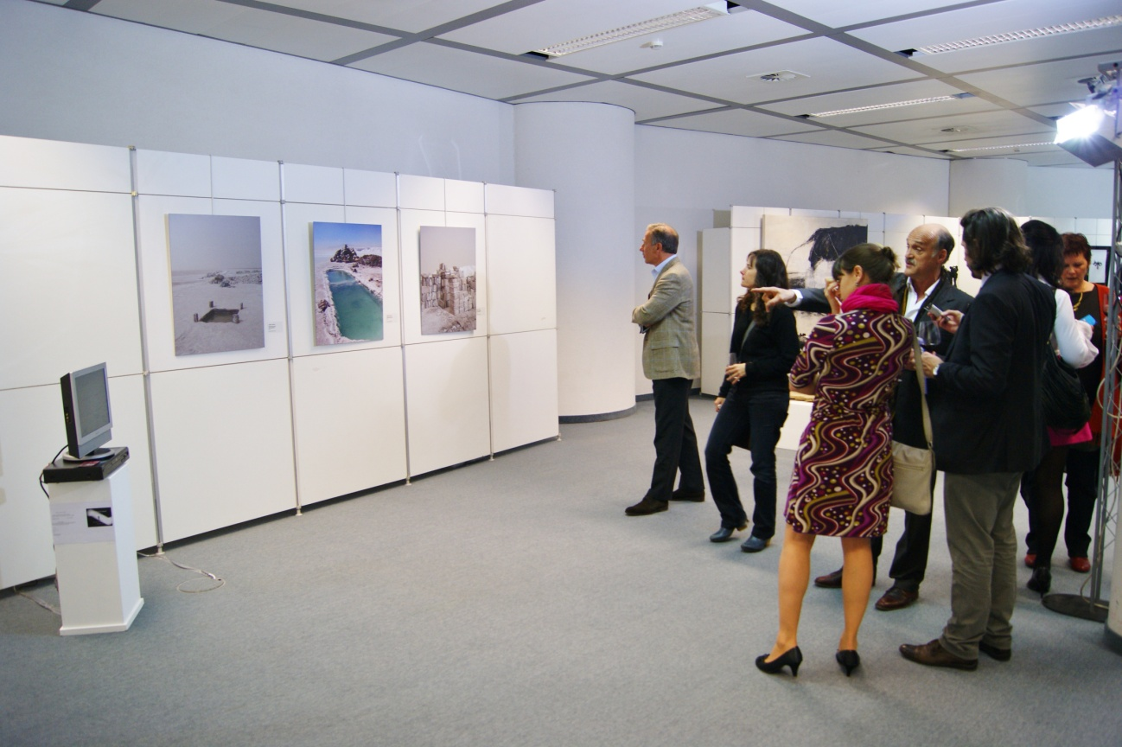

PUENTES_FLEMISH PARLIAMENT ADMINISTRATION_EMBASSY OF ARGENTINA_2013
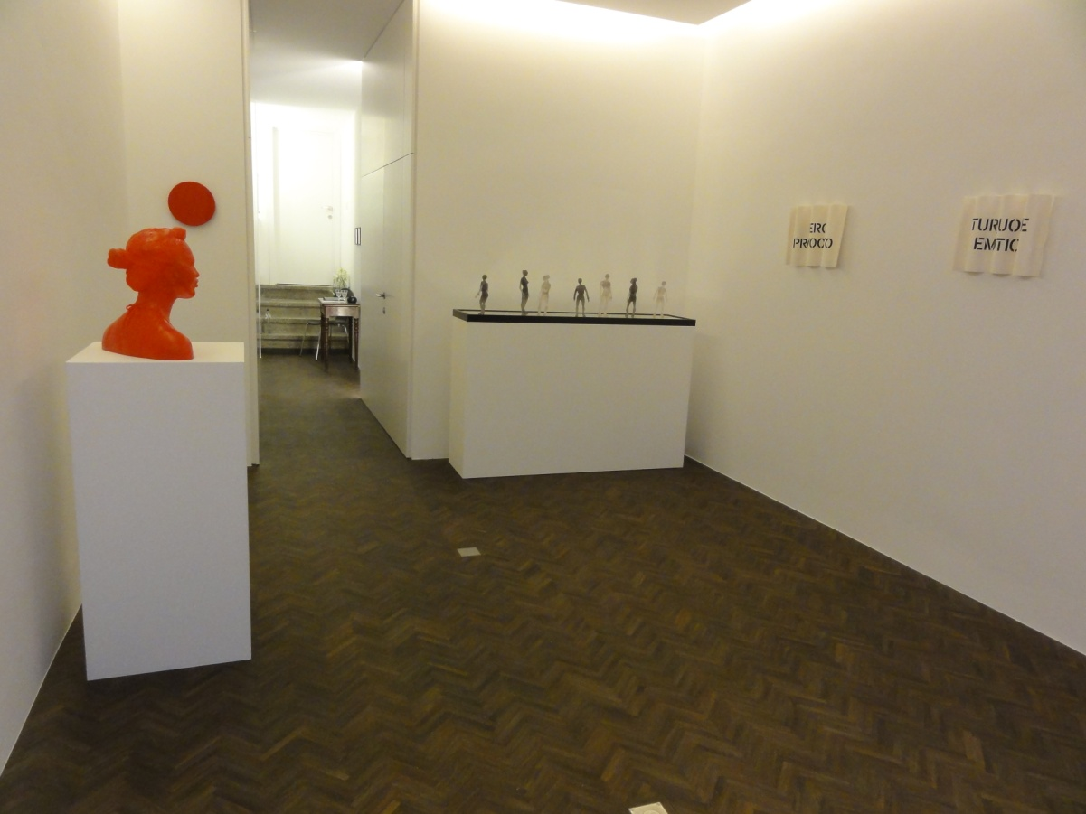

FIRST EXHIBITION CECILIA JAIME GALLERY_2012

"In Cecilia Jaime’s photographic work, the faraway landscapes,
depicting a kind of South American no-man's-land, seem to distance
themselves from any recognizable historical past. Nearly devoid of
human presence, their surfaces rather lay bare through trace elements
the basic production activities of the area (salt industry, in this
case). Yet, these traces are like scars on the landscape that provide
enigmatic clues to the traumatic political past of Argentina. The
various anthropomorphic forms--from the body-like piles of bags to
the "invisible" humanoid shapes that lie behind them and which
populate this seductively desolate natural scene--function like
warning signs of a disturbing social machinery
Curator Marko Stamenkovic, Nov09

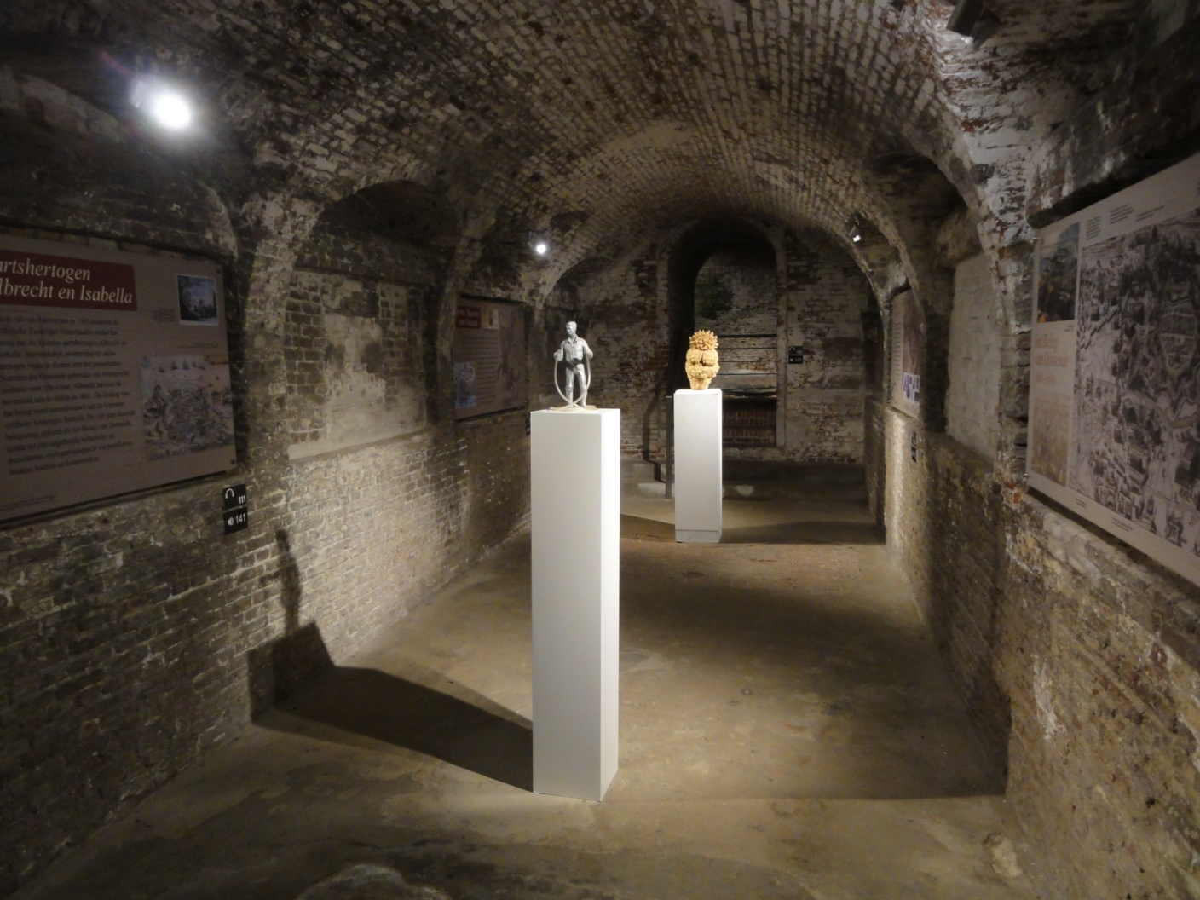

FORT NAPOLEON, Oostende _ MARINA ART_2013

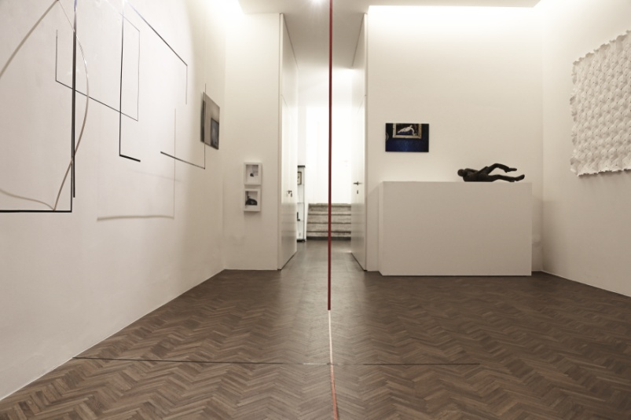

SUMMER CAMP#2 SHOW AT CECILIA JAIME GALLERY_2015
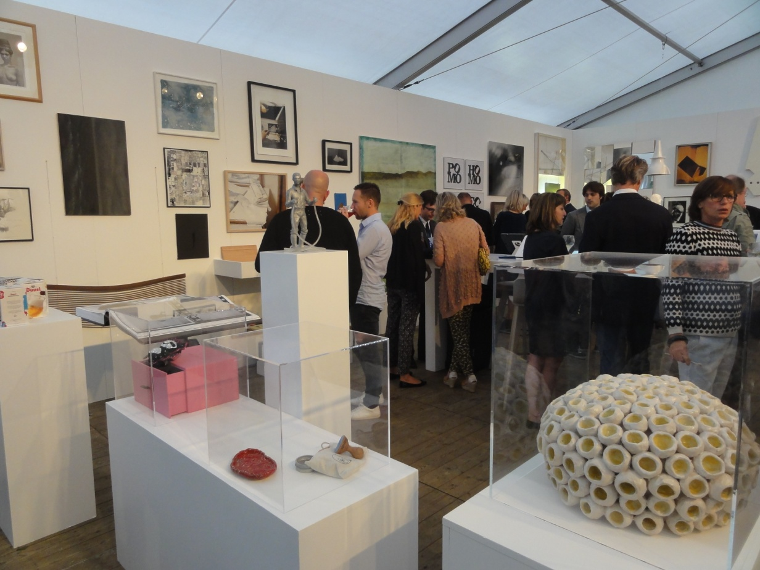

"THE LEVELLER"_sculpture_ACTION IN MUSEUM DHONDT-DHAENENS_PADDLE8 & CHRISTIE'S_2014

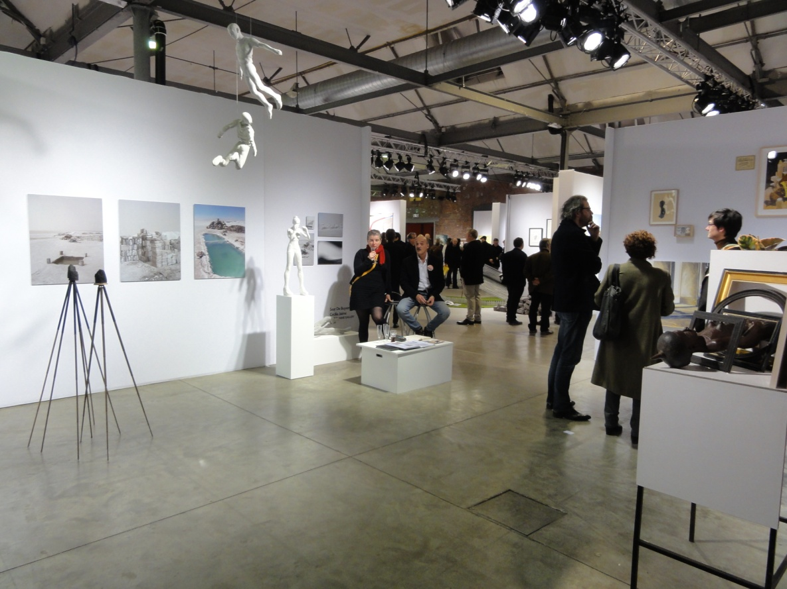

BAD_BELGIAN ART AND DESIGN_ Fair at GHENT_2016_

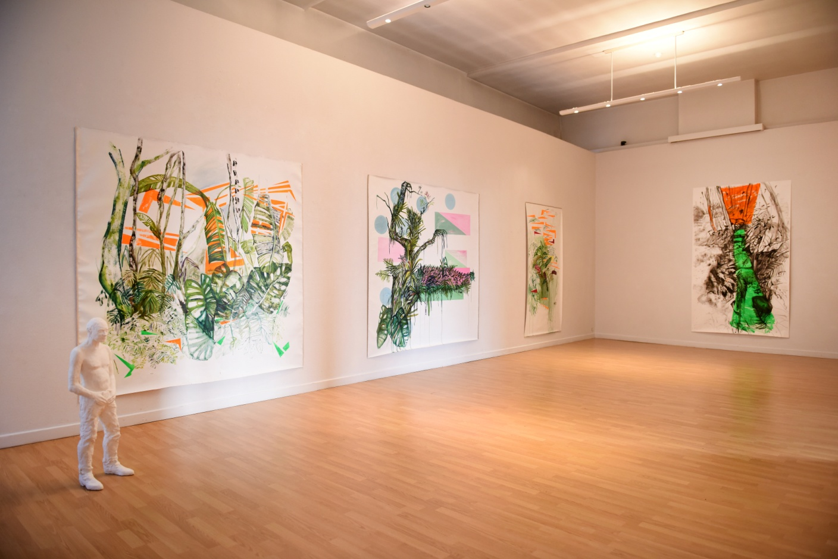
Solo Show Kasteel Claeys-Bouuaert , Gent- Ambassade of Argentine & City of Ghent ,2017
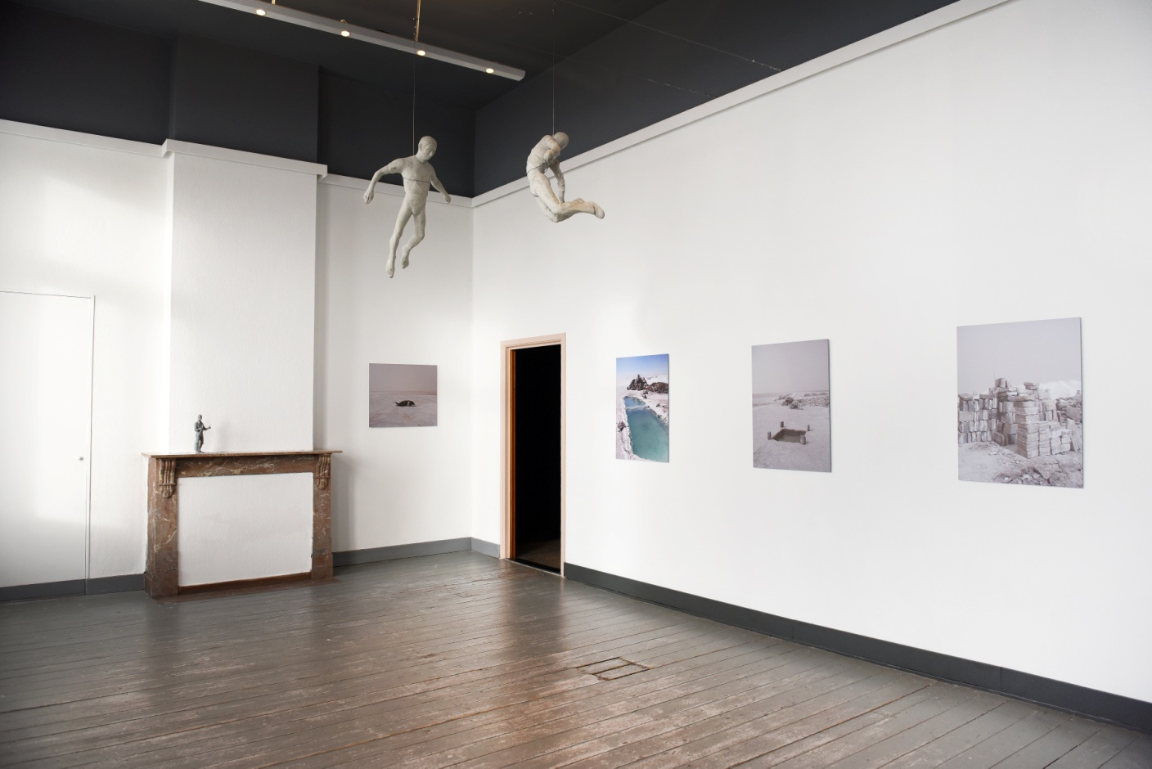

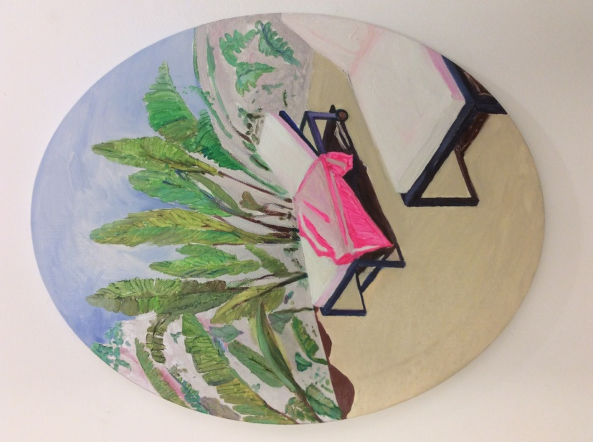

Siesta en el jardín, Yerba Buena, oil on canvas, 50 x 40 cm 2019

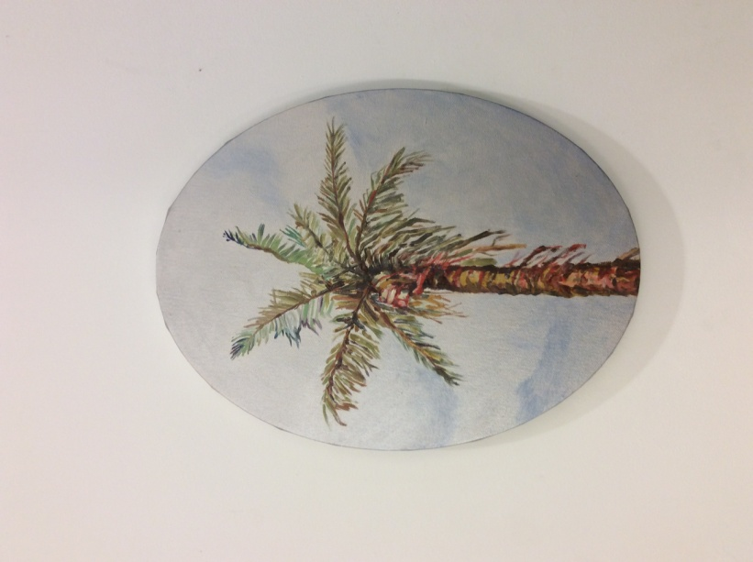

Palm Tree with silver sky, oil on canvas, 40 x 30 cm 2019
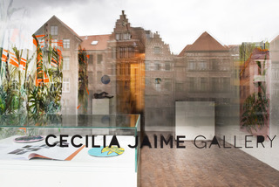

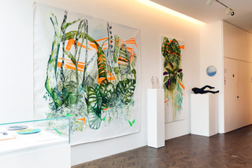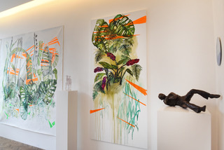
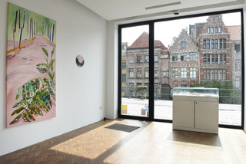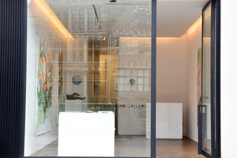

'Gardens' Solo Show Cecilia Jaime, 2018

Cecilia Jaime ‘Over de subtiele oneindigheid van toets en kleur’

‘Elk kunstwerk is kind van zijn tijd, vaak is het de moeder van onze gevoelens’, schreef de Russische kunstenaar Wassily Kandinsky (1866-1944) in zijn artistieke manifest Over het geestelijke in de kunst. Daarin benadrukt hij de innerlijke noodzakelijkheid voor het tot stand komen van een kunstwerk, waarbij de vorm ervoor zorgt dat die innerlijkheid des te meer tot uiting komt. Dit gedachtegoed lijkt ook een credo te zijn van de in Argentinië geboren kunstenaar Cecilia Jaime, in wiens werk elke vorm (en dus ook kleur) iets innerlijks in zich herbergt.
De natuur van haar Argentijnse vaderland, die vandaag in tijden van climate change dierbaarder en kostbaarder is dan ooit, en de weergave ervan in talrijke kleuren die haar palet eigen zijn, zijn onuitputtelijke inspiratiebronnen voor Cecilia Jaime. In haar recente werken zijn er weinig mensen te zien, hoewel ze soms in hun desolaatheid de aanwezigheid van mensen (bijvoorbeeld aan de hand van een zwemmatras of een shelter) suggereren, alsof ze zonet even uit het doek gewandeld zijn. Vaak wordt er met haar blik en penseel ingezoomd op details van planten en vegetatie, of toont ze een doorkijk doorheen het bladerdak.
Kleur, in al zijn oneindige vormen, domineert en frappeert in haar werken. De kleur is bepalend om de subtiliteit ervan weer te geven, om het spel van contrast tussen donker en licht te onderlijnen, om de kijker te confronteren met hoe haar/zijn blik en haar/zijn manier van kijken ook kenmerkend zijn voor een schilderij.
De kleuren die Cecilia Jaime in haar werken hanteert, maken niet alleen onderling verbanden, maar bestaan vaak an sich: wanneer we een bepaald fragment uitlichten in een concreet schilderij. De kleur loopt door tot aan de randen van het doek, alsof er zich ook een beeld aan de achterkant van het werk kan bevinden. De verschillende groenen van planten worden soms gecombineerd met krachtige, niet-weifelende toetsen fluoverf, die het beeld niet alleen breken, maar er ook als een soort van hedendaagse stoorzenders onlosmakelijk mee verbonden zijn.
Hoewel Cecilia Jaime nu eens met olieverf, dan weer met acrylverf schildert, al naargelang, zijn er werken waarin ze beide in een- en hetzelfde werk combineert. Compositie is belangrijk. Zo kan één schilderij bestaan uit 9 afzonderlijke doeken die als een puzzel in elkaar vallen en tegelijkertijd één werk vormen hoewel elk afzonderlijk deel ook op zichzelf bestaat en betekenis geeft. Fysiek fungeren ze als een modulair systeem. De tussenruimte van de muur waarop elk werk bevestigd is, speelt eveneens een rol en verleent het werk een bijna sculpturaal aura. Tegelijkertijd is er het visuele spel tussen de doeken onderling, die een continuïteit genereert: een deel van een bladerdak of een varen loopt verder tot in het volgende doek. Day and Night worden verbonden.
In Goldfish Lake wordt het perspectief verscherpt zodra de kijker van op een afstand kijkt. Hoewel dit werk in al zijn kleurenrijkdom en diepte (in het water, in het landschap) op het eerste gezicht als niet realistisch wordt ervaren, komt het toch heel werkelijk over. Het is een paradox die wel vaker doorspekt is in het werk van Cecilia Jaime: zo ook in de werken waarin ze de tekenwaarde van een beeld combineert met zeer afgelijnde verfstreken. De luminositeit is opvallend. De vormen van haar doeken, denken we bijvoorbeeld aan de ovalen vorm waarop een palmboom prijkt, zijn bepalend.
De werken van Cecilia Jaime, waarin een sterk ruimtelijk gevoel steeds aanwezig is, liggen nooit dik in de verf. Diepte en oneindigheid worden gecreëerd door de manier waarop ze de verf op doek zet en met compositie en perspectief speelt.
Kleur is bepalend in haar subtiel oeuvre, zowel door de compositie als door de manier waarop het tafereel ervaren wordt. De toets is behendig, opbouwend, gevoelig. Elke penseelstreek genereert de volgende. Vlakken versterken elkaar of contrasteren.
Soms gebruikt Cecilia foto’s van de haar omringende werkelijkheid als een herinnering voor een ervaring, maar het werk ontstaat al doende, waarbij het denken en doen samenvallen, zodat ze vaak al schilderend afwijkt van de originele foto en die foto slechts als vertrekpunt gebruikt.

Over de gestileerdheid van de beweging in de vorm

‘Ongeopenbaard als het ware, als iets dat hem toevertrouwd wordt, moeten de vormen door zijn vingers gaan om zuiver en gaaf in zijn werk te zijn’, schreef de dichter Rainer Maria Rilke begin twintigste eeuw over het werk van Rodin.
De sculpturen van Cecilia Jaime, die bestaan uit zeer uiteenlopende materialen zoals brons, polyurethaan, polyester of epoxy ontstaan zeer intuïtief en direct. De zuiverheid van de vorm die ontstaat na het ambachtelijke proces van het maken aan de hand van een mal, treffen.
Gestileerde figuren liggen op de grond. Een buste kijkt je aan. Of bij Falling Man, die gemaakt is van epoxy, worden verschillende ‘vallende figuren’ in een eigentijdse constellatie als een installatie opgehangen in de lucht. Wat daarbij opvalt, is de beweging die in de figuur verwerkt is, zodat het aanwezige idee van het springen, en dat in de lucht, nog eens extra benadrukt wordt.
Een bronzen sculptuur ligt op de grond om het plastische en de ruimtelijke werkelijkheid ervan te tonen. Ook hierbij springen de beweging (weg van het louter statische) en het organische die in het beeld schuilen, in het oog.
Bij een sculptuur is de wet van de onderlinge verhoudingen van belang en daar is Cecilia Jaime zich van bewust: zo worden bijvoorbeeld in de sculptuur High Heels de benen van een meisje met een Degas-achtig hoofd bewust te lang gemaakt om het idee van het seksisme te benadrukken in een maatschappij die gebombardeerd wordt met beelden en producten om jong, efficiënt en mooi te zijn.
In Face to Face wordt een vrouw-manrelatie geportretteerd. De twee bustes kunnen samen worden geëxposeerd, maar fungeren ook alleen op een meer universele en tijdloze manier.
In haar sculpturen brengt Cecilia Jaime soms verschillende materialen samen. Capeman is een polyurethaansculptuur, gebaseerd op een ambachtsman die ze in de zoutvelden van Argentinië heeft ontmoet, waarover ze een cape van papier heeft gedrapeerd. De plasticiteit van het papier genereert de beweging in het beeld en draagt dezelfde witachtige kleur als het beeld zelf. Het no-nonsense effect van het papier contrasteert en valt tegelijk samen met het beeld gemaakt in verschillende technieken. Cecilia Jaime speelt wel vaker met deze dubbelheid en gelaagdheid. In het werk de Leveller integreert Cecilia Jaime bij een in grijs polyurethaan gemaakte figuur een plastic buis, bedoeld om de stijging van het water in de oceanen te meten.
Van haar losgemaakt getuigen deze werken van een zelfstandig, geestelijk ademen dat ook materieel verwerkelijkt is. Aan u allen om dit oeuvre te ontdekken.
Inge Braeckman, Gent 2019.

CECILIA JAIME- WWW.CECILIAJAIME.COM-INFO@CECILIAJAIME.COM - KRAANLEI 55-9000 GENT- M:+32(0)476645557

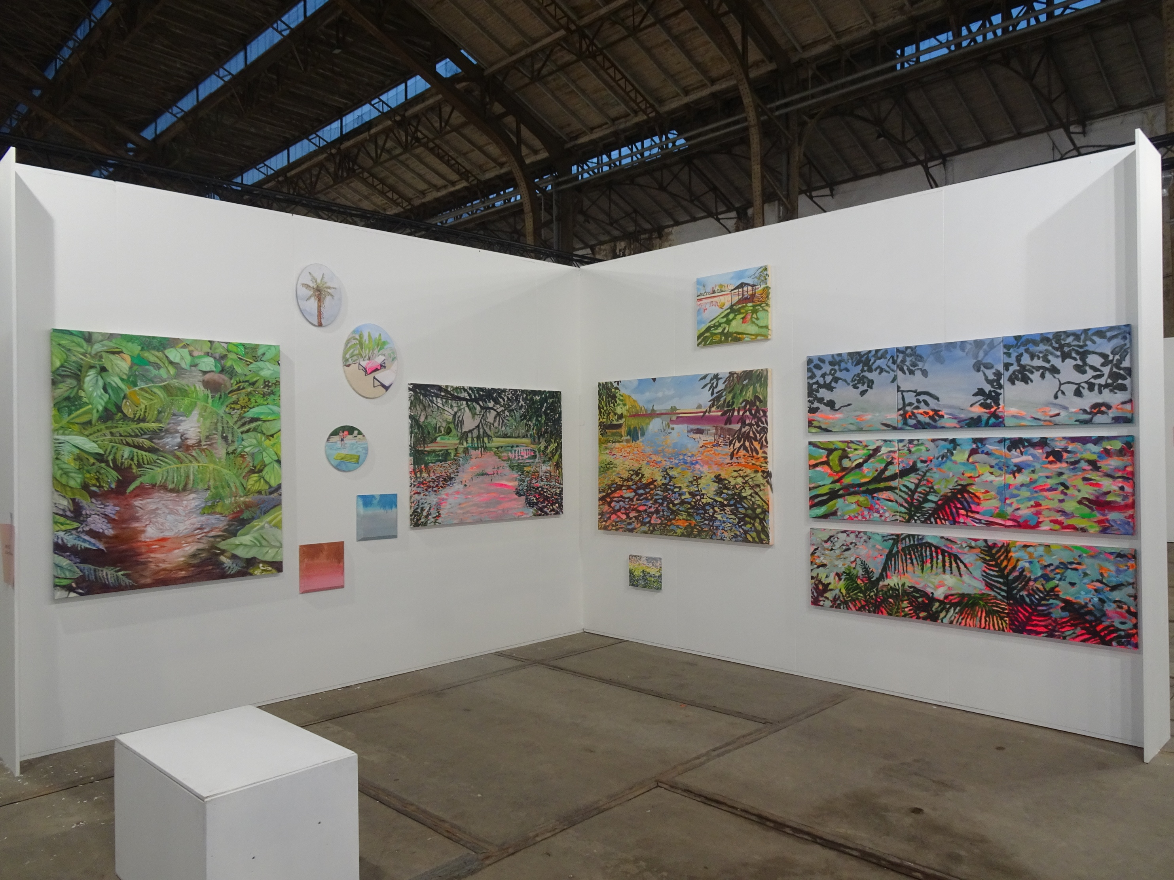

C E C I L I A J A I M E

S T U D I O

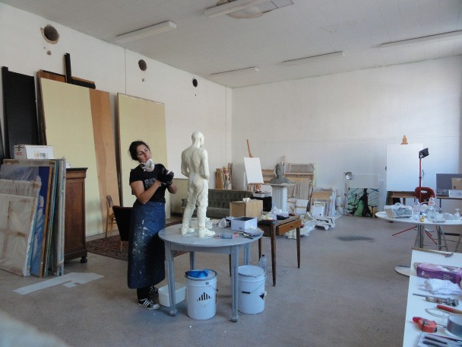

Cecilia Jaime, Artist in residence at Nucleo from 2006 _Studio at Lindelei 2012

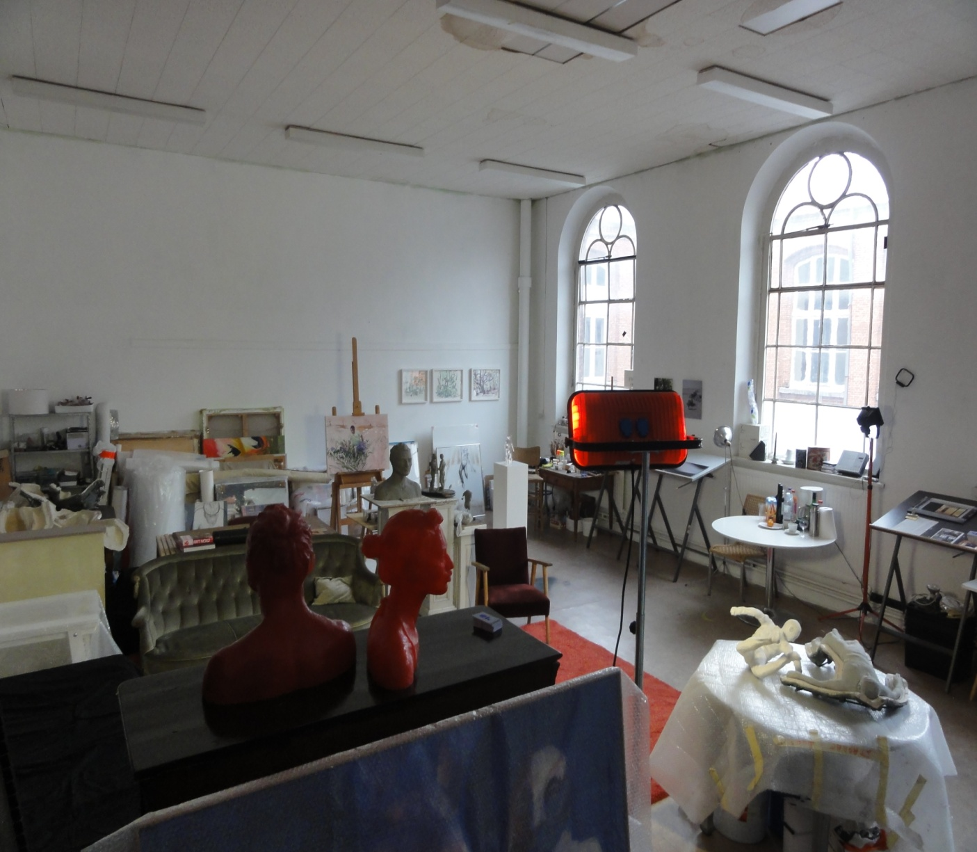

Cecilia Jaime, Artist in residence at Nucleo _Studio at Lindelei 2016

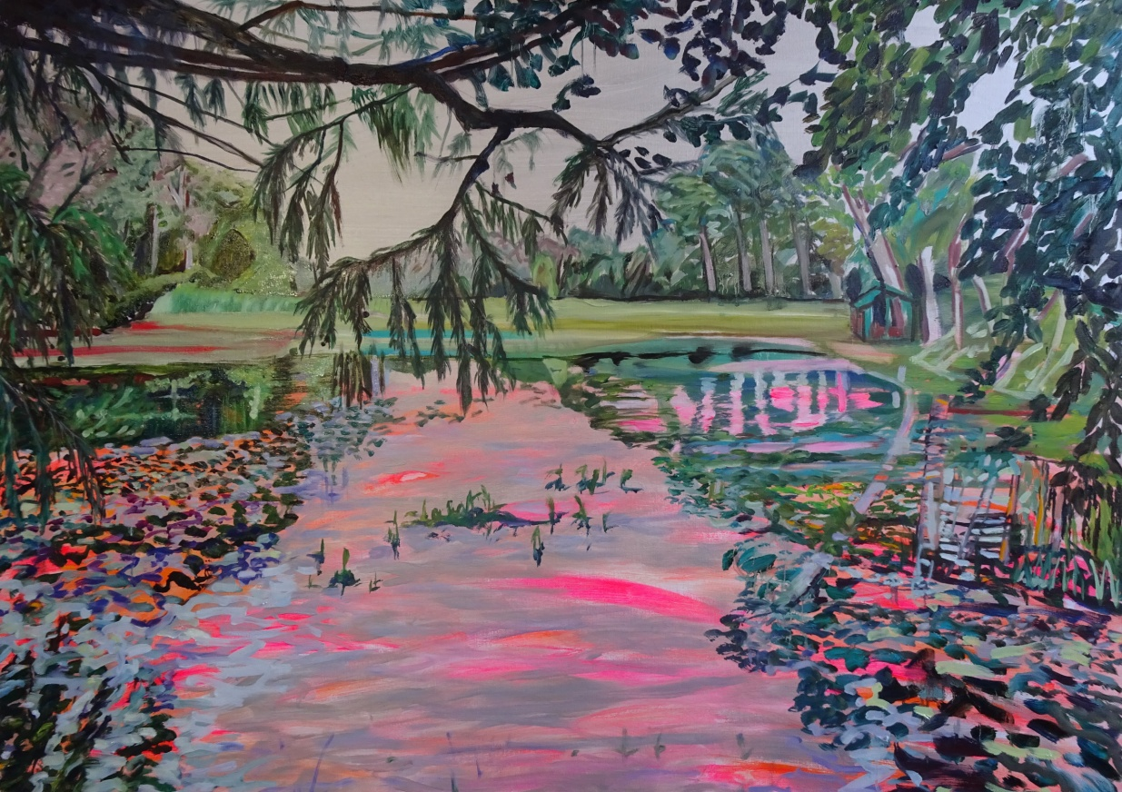

PINK LAKE 100 X 140 CM- oil on canvas,2019

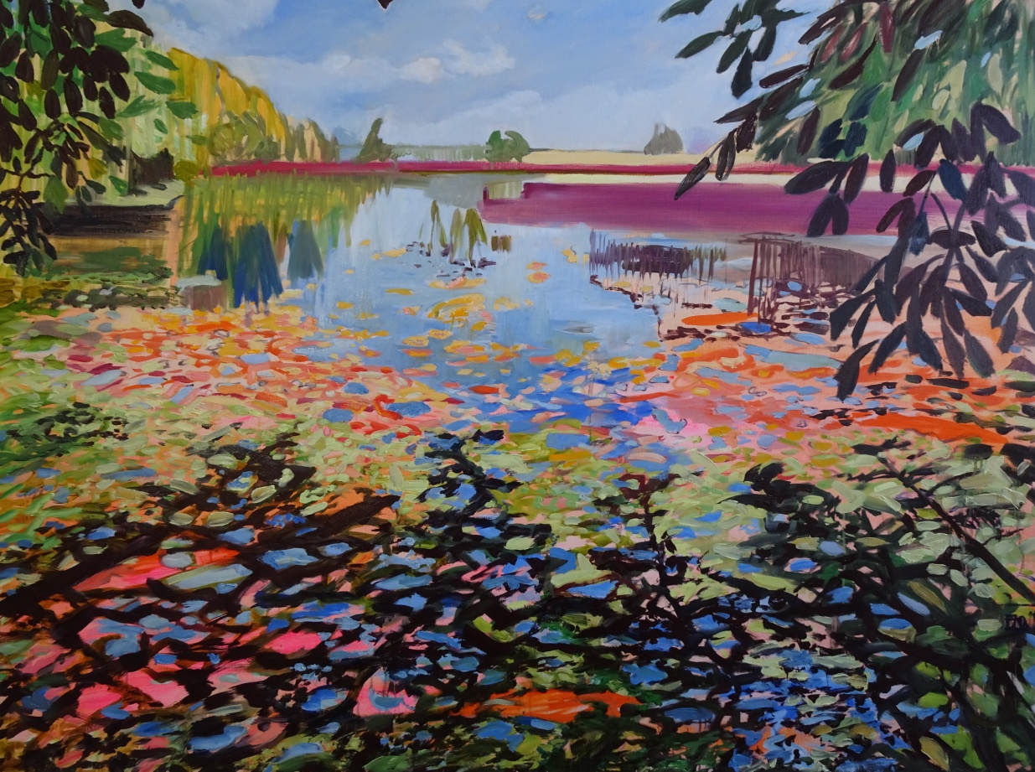

THE GOLD FISH LAKE- 120 X 160 CM oil on canvas, 2019
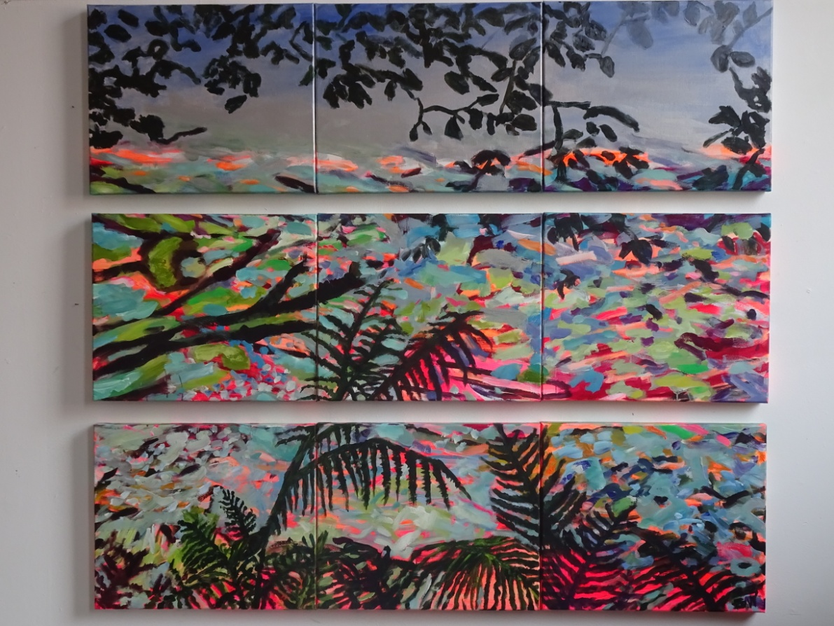

Day and Night, oil on canvas, 2019

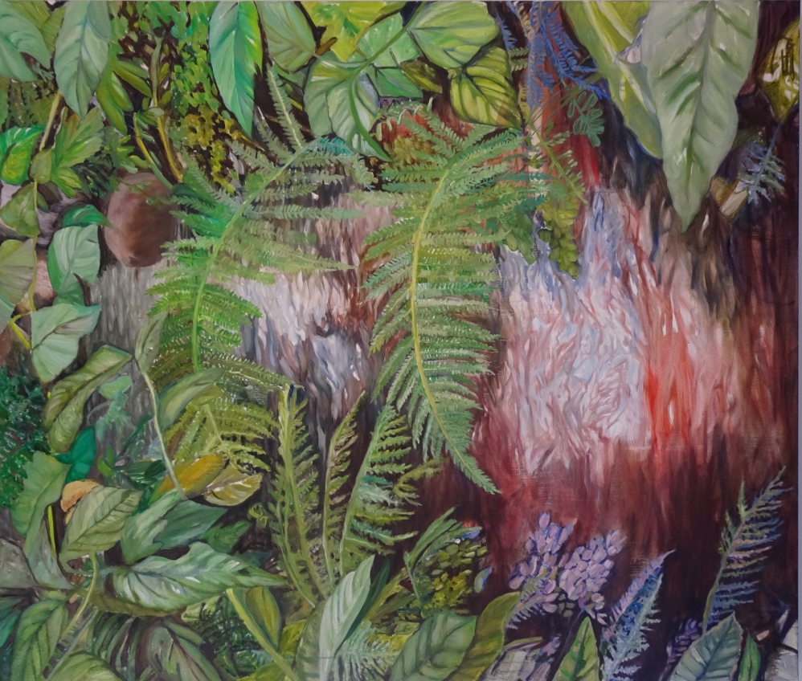
RIO, 140 x 120 cm oil on canvas , 2019

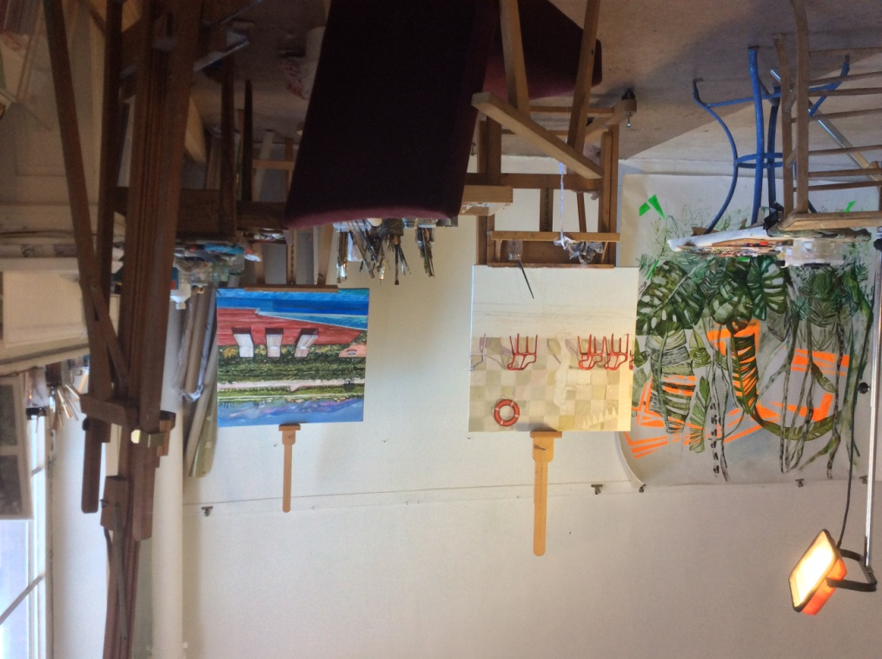
Studio at Lindelei

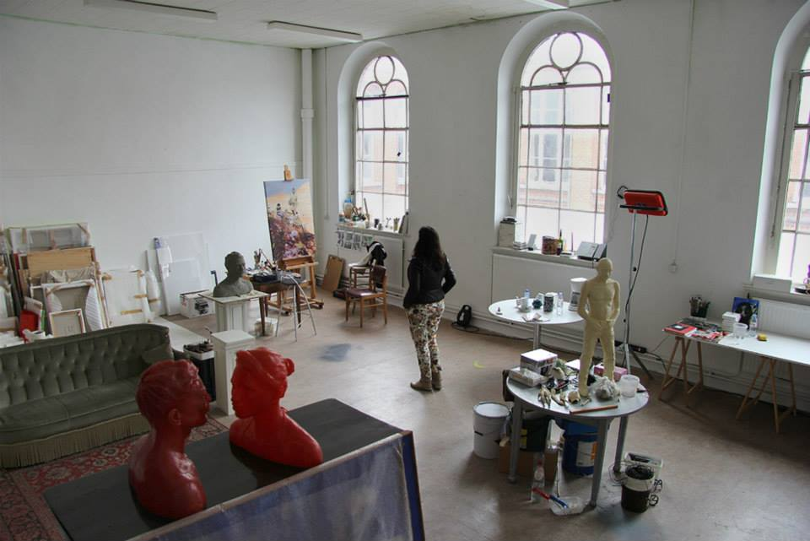
Studio at Lindelei

CECILIA JAIME

www.ceciliajaime.com

info@ceciliajaime.com

+32 (0) 476/ 64 55 57

